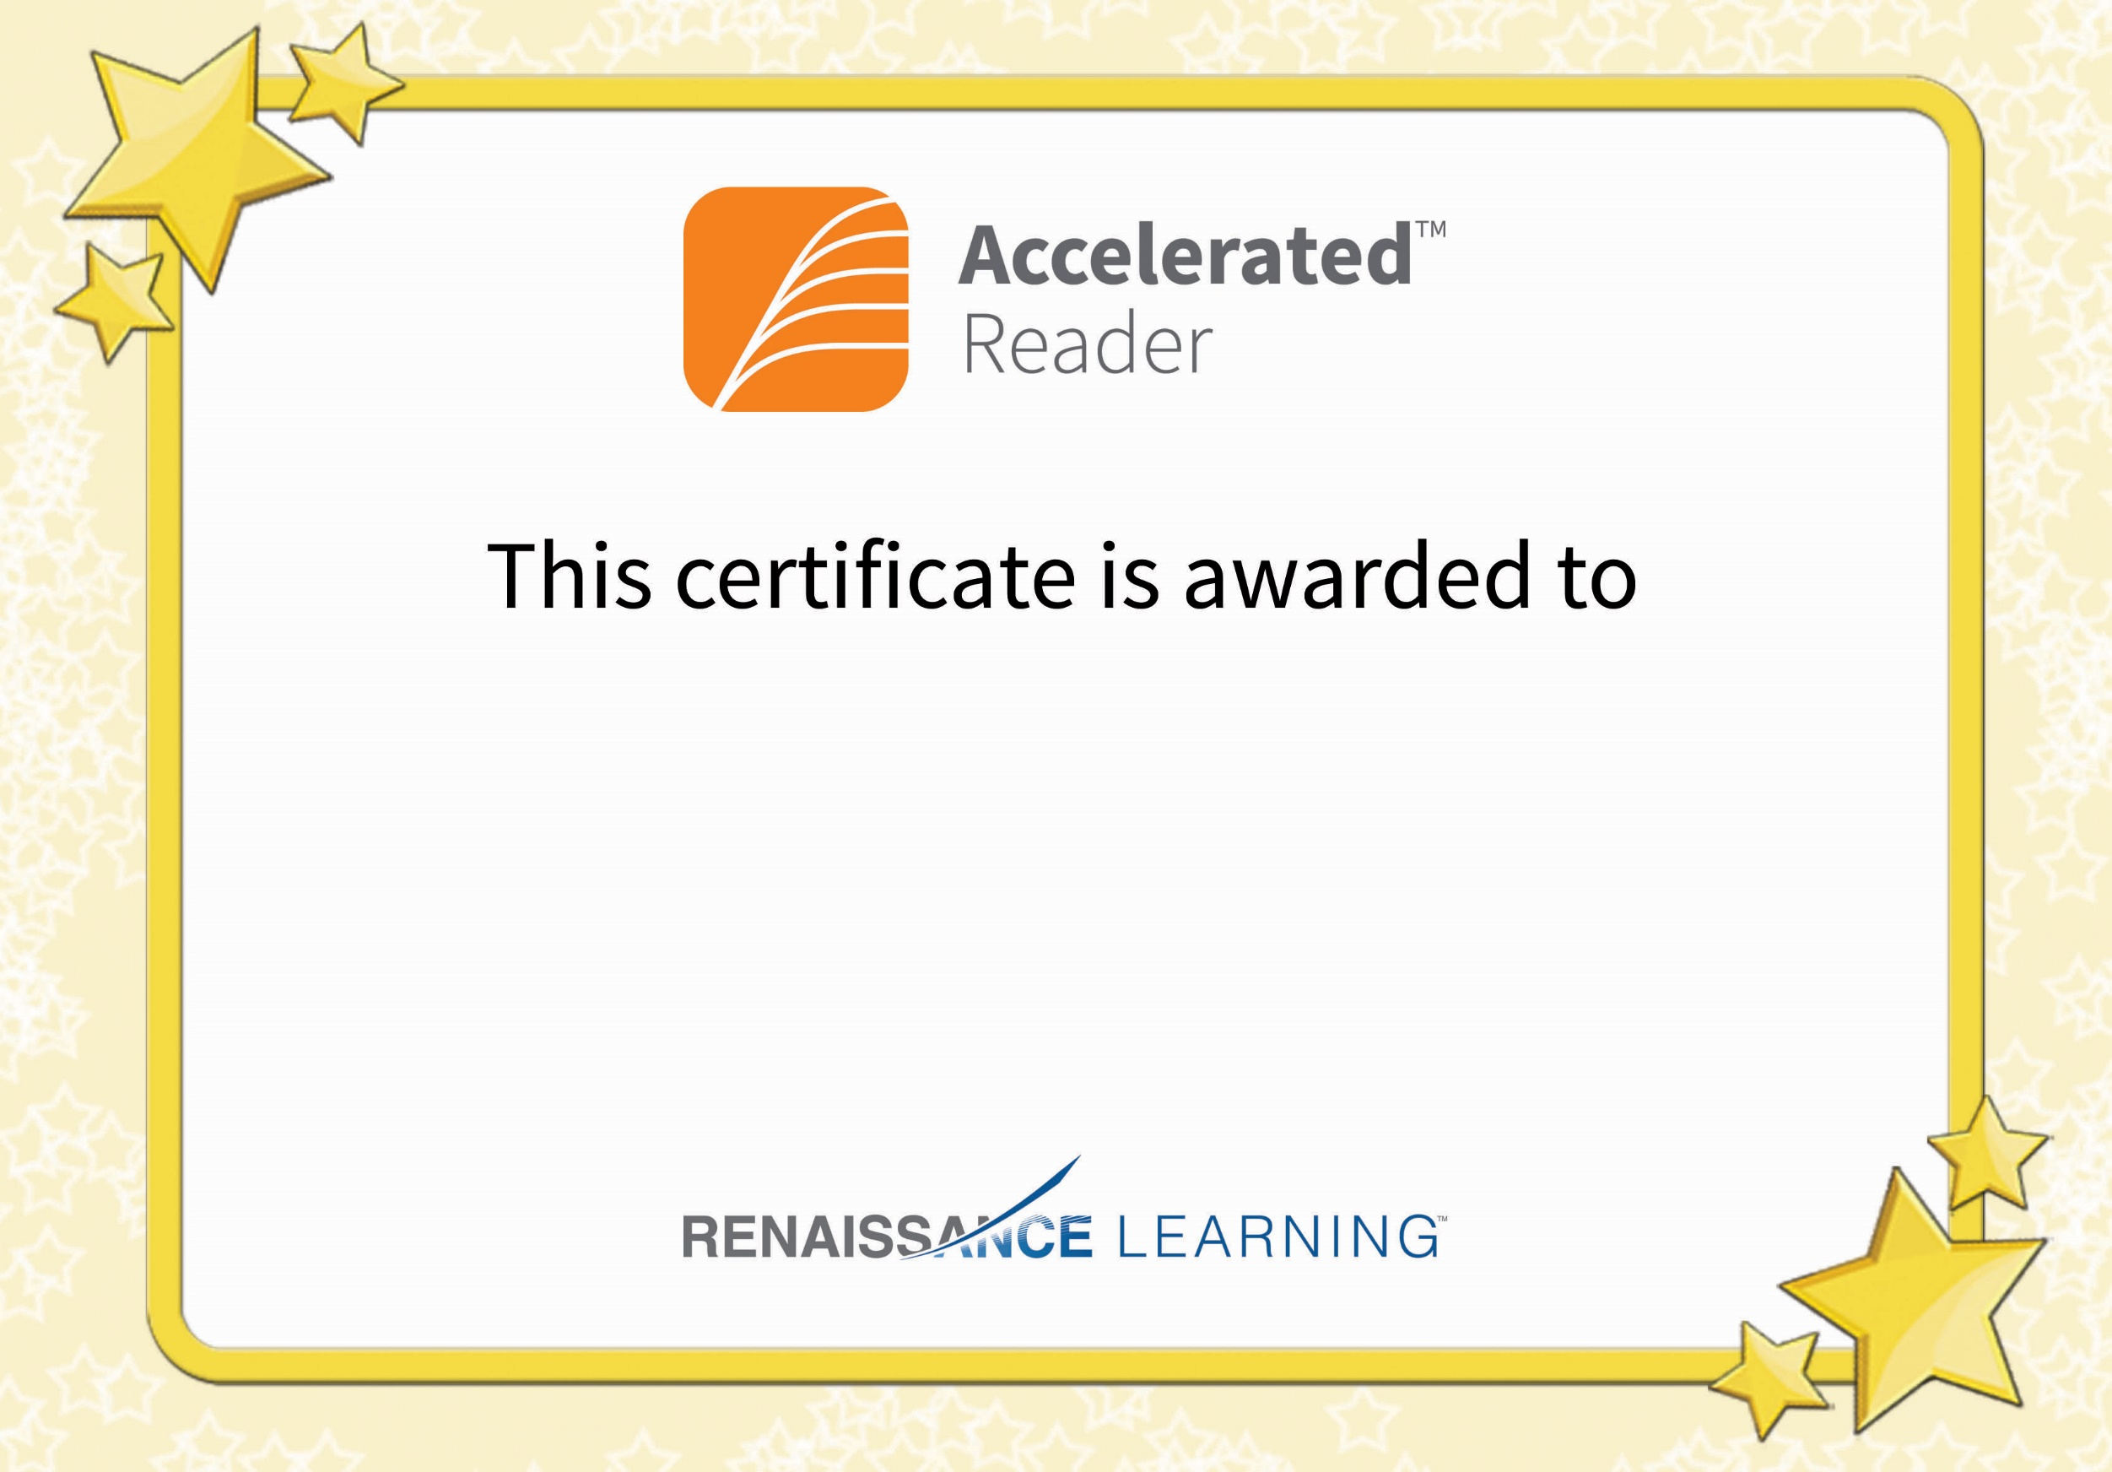

Emma Stevenson

For reaching your Accelerated Reader target