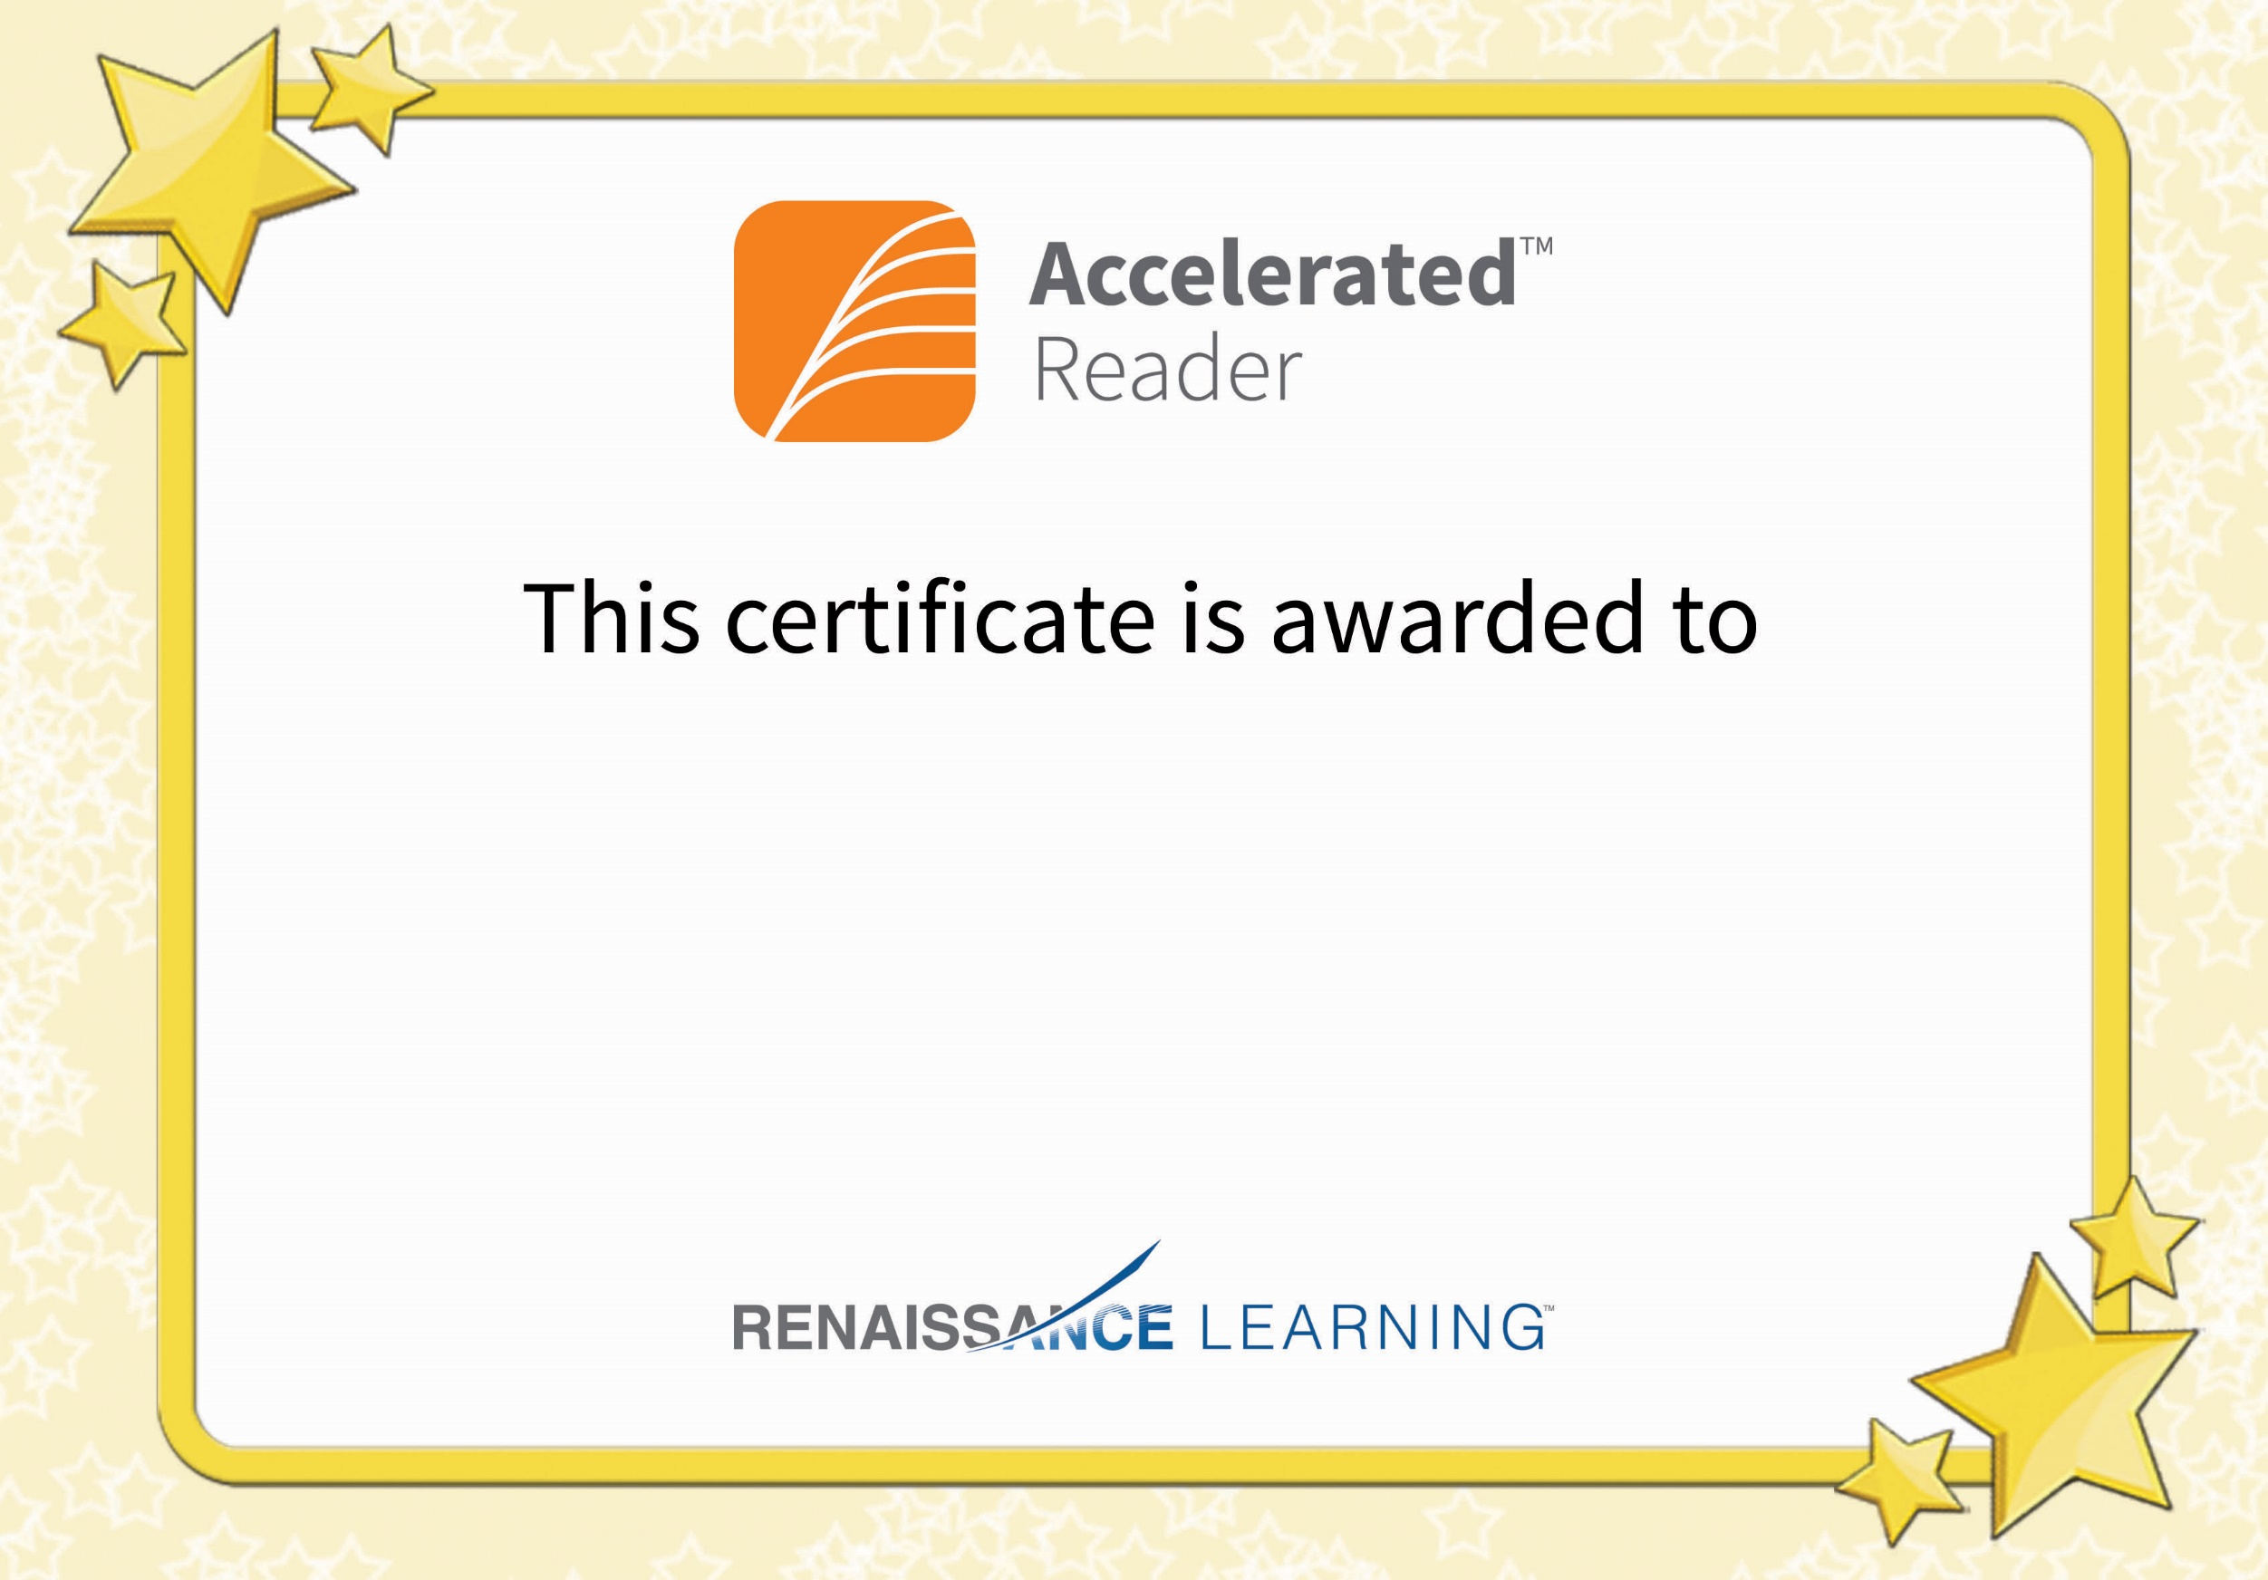

Nojus Petkevicius

For reaching your Accelerated Reader target