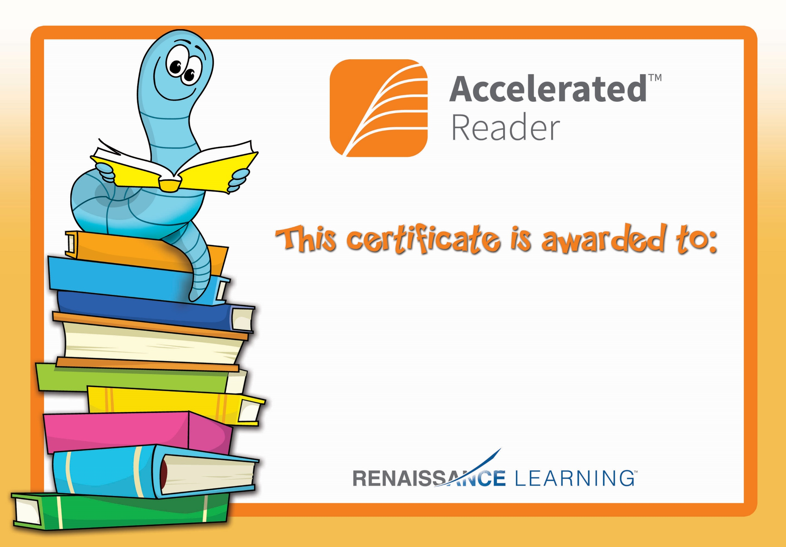

Aoife McC

For reaching her AR target