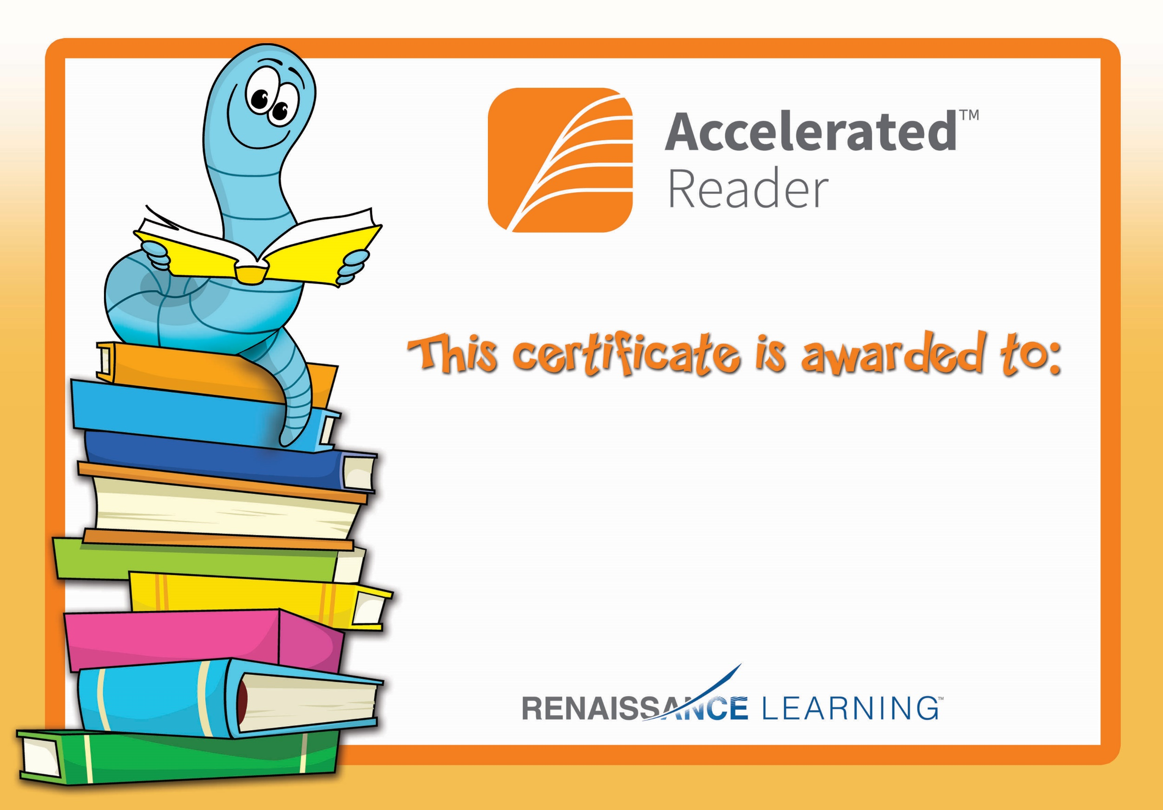

Matthew

Congratulations on reaching your Accelerated Reading target!