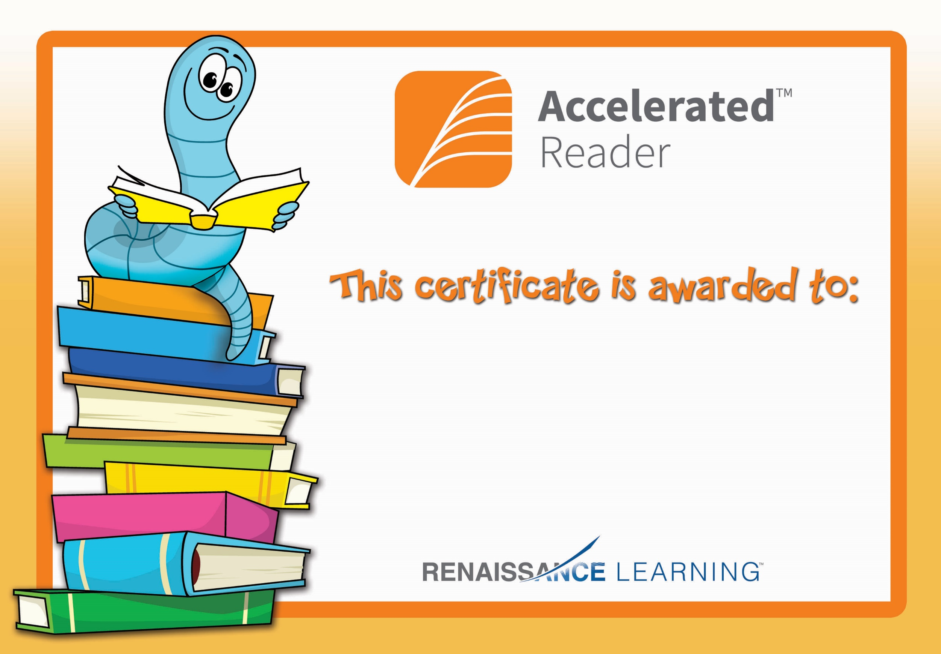

Harry Mc Alinden

Congratulations you reached your target.