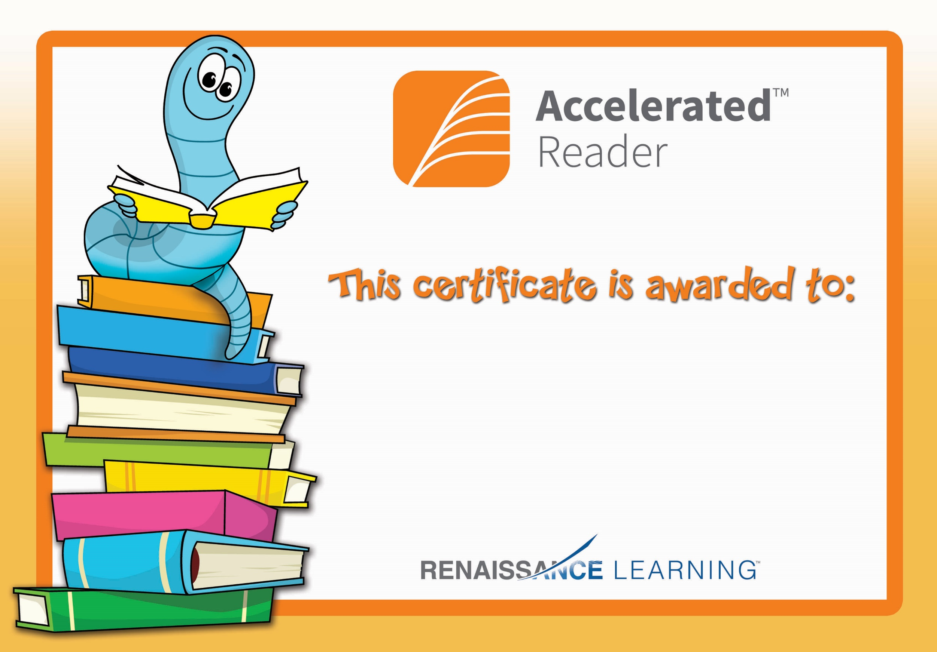

Jacob Mc Cann

Congratulations you reached your target.