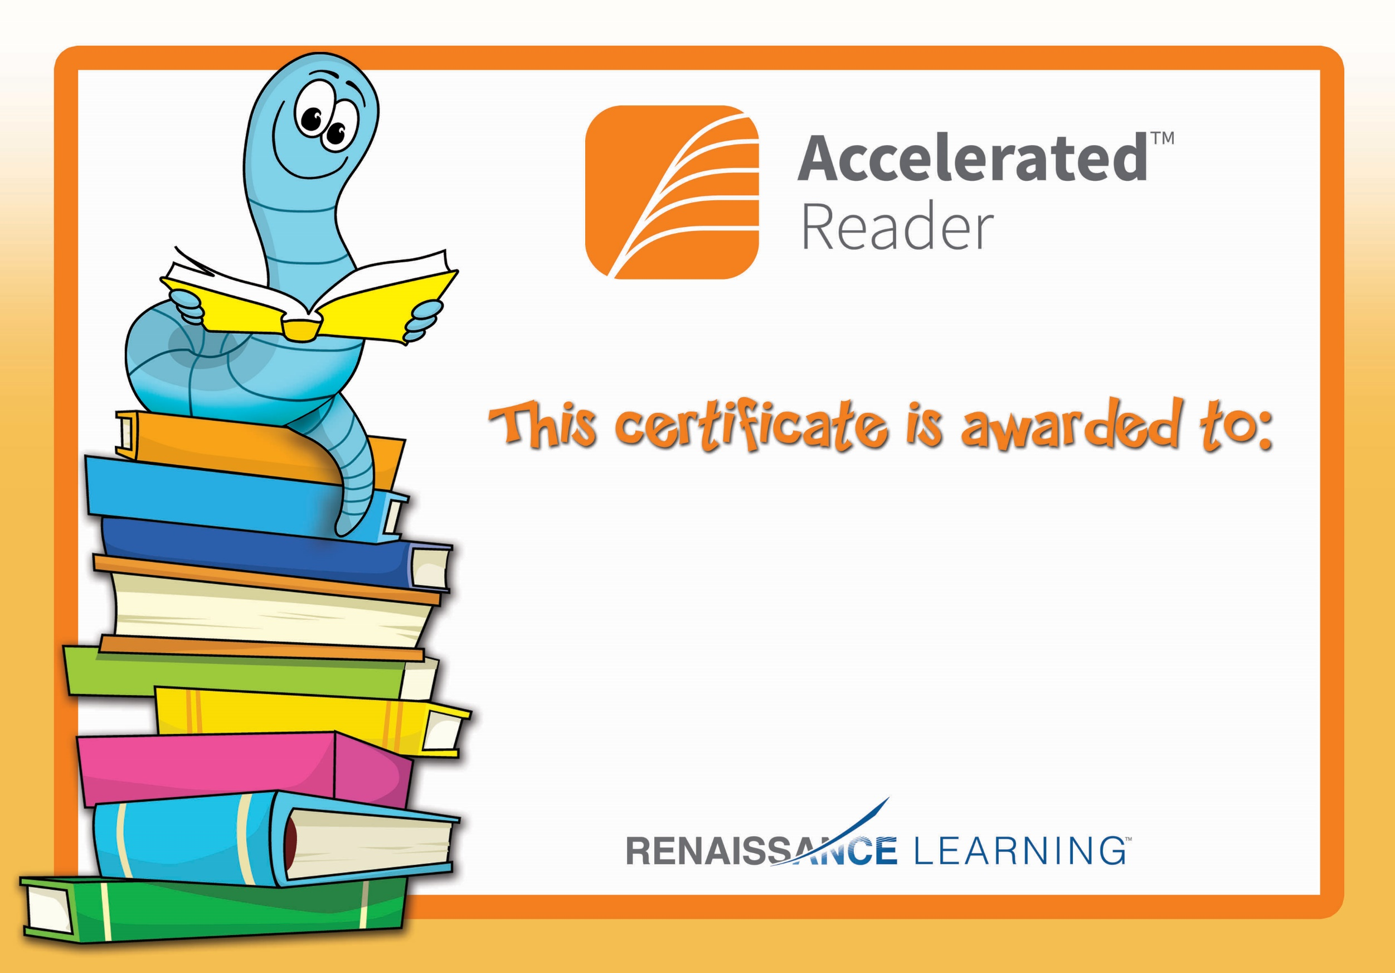

***Siubhan***

**For reaching her**

**Term 3 AR Target.**

**Well done!**