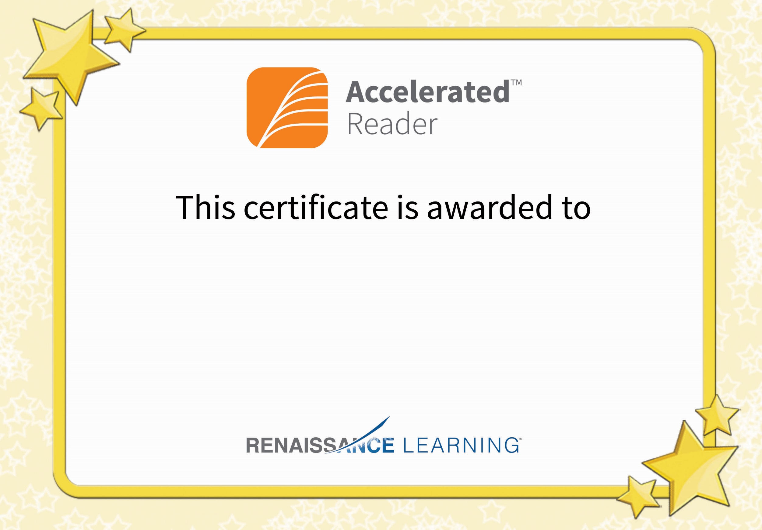

Emma Stevenson

Congratulations on reaching your AR target.