Fan the Flame 2020

Sensory Bottles for Year Seven and Sixth Class Pupils



“The Beatitudes Reveal the Path to True Happiness…they Always Lead to Joy”

(Pope Francis)

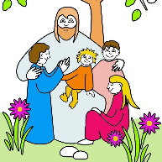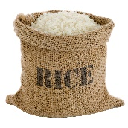[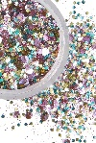](https://www.google.co.uk/url?sa=i&url=https%3A%2F%2Fwww.inyour-dreams.com%2Fcosmic-purple-unicorn-bio-glitter-biodegradable-glitter%2F&psig=AOvVaw0d8m5uld7CSQxeSE1LGbW7&ust=1589897747689000&source=images&cd=vfe&ved=0CAIQjRxqFwoTCNDnsOfMvekCFQAAAAAdAAAAABAJ)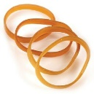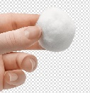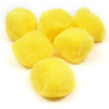[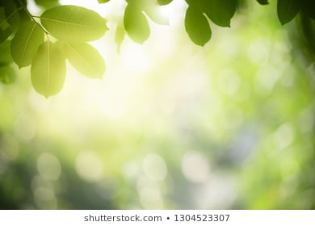](https://www.google.co.uk/url?sa=i&url=https%3A%2F%2Fwww.shutterstock.com%2Fsearch%2Fnature%2Bbackground&psig=AOvVaw0TXAYye0WmpmdsOwiN-miP&ust=1589895718775000&source=images&cd=vfe&ved=0CAIQjRxqFwoTCNDF8KXFvekCFQAAAAAdAAAAABAD)

**Primary School Sensory Bottle**

***Create a sensory bottle to remind you of your years at Primary School. When you shake it, you can say thank you to God for the gift of all these wonderful people in your primary education.***

***What you need…***

***Instructions…***

1. Take an empty plastic bottle.
2. Put a yellow pom-pom, cotton wool, an elastic band, some glitter and some rice inside.
3. Fill the bottle with water.
4. Put a lid on the bottle and secure with cello tape.
5. Cut out picture of Jesus and stick onto the front.
6. Say prayer below while shaking and looking at sensory bottle.

***Dear God…….***

***Yellow pom-pom: thank you for all the people who made me smile at primary school,***

***Cotton wool: thank you for the staff who cushioned me during a bad day at school,***

***Elastic bands: thank you for the teachers who stretched me so I achieved my best,***

***Glitter: thank you for my friends who played with me and helped me to sparkle***

***Rice: thank you for all the food I ate at school,***

***Photo of Jesus: thank you Jesus for always being by my side***

***Amen.***



**Cut out and stick onto the outside of your sensory bottle.**

[](https://www.google.co.uk/url?sa=i&url=https%3A%2F%2Fwww.thegospelcoalition.org%2Farticle%2F3-things-didnt-know-sermon-mount%2F&psig=AOvVaw06mzc4iKBtCyWlOuYev342&ust=1589988865526000&source=images&cd=vfe&ved=0CAIQjRxqFwoTCNiE5aegwOkCFQAAAAAdAAAAABAD)[](https://www.google.co.uk/url?sa=i&url=https%3A%2F%2Fwww.inyour-dreams.com%2Fcosmic-purple-unicorn-bio-glitter-biodegradable-glitter%2F&psig=AOvVaw0d8m5uld7CSQxeSE1LGbW7&ust=1589897747689000&source=images&cd=vfe&ved=0CAIQjRxqFwoTCNDnsOfMvekCFQAAAAAdAAAAABAJ)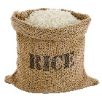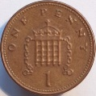[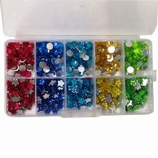](https://www.google.co.uk/url?sa=i&url=https%3A%2F%2Fwww.ebay.co.uk%2Fitm%2FAssorted-Christmas-Card-Craft-Gems-Jewels-Rhinestones-Embellishments-Sequin-%2F392121640558&psig=AOvVaw1CPcrtUMklwpEQWObzjKUi&ust=1589991786976000&source=images&cd=vfe&ved=0CAIQjRxqFwoTCIirtZCrwOkCFQAAAAAdAAAAABAD)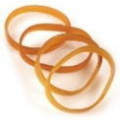[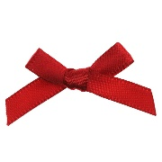](https://www.google.co.uk/url?sa=i&url=https%3A%2F%2Fwww.wowvow.co.uk%2Fred-ribbon-bows-7mm.html&psig=AOvVaw2oWZCmKvAC8yVJOzTOkpSF&ust=1589989516565000&source=images&cd=vfe&ved=0CAIQjRxqFwoTCJDJt9WiwOkCFQAAAAAdAAAAABAD)[](https://www.google.co.uk/url?sa=i&url=https%3A%2F%2Fwww.health.harvard.edu%2Fstaying-healthy%2Fhow-much-water-should-you-drink&psig=AOvVaw3jMucOrnO0jySLtDlCf2BH&ust=1589989343328000&source=images&cd=vfe&ved=0CAIQjRxqFwoTCKC7pYSiwOkCFQAAAAAdAAAAABAD)[](https://www.google.co.uk/url?sa=i&url=https%3A%2F%2Fwww.vectorstock.com%2Froyalty-free-vector%2Ffeather-vector-1028154&psig=AOvVaw3BvjVcUO_8aB6yptwOPIDI&ust=1589989294824000&source=images&cd=vfe&ved=0CAIQjRxqFwoTCIjV6uuhwOkCFQAAAAAdAAAAABAD)[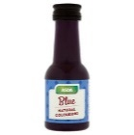](https://www.google.co.uk/url?sa=i&url=https%3A%2F%2Fgroceries.asda.com%2Fproduct%2Fcake-decorations%2Fasda-blue-natural-food-colouring%2F80624306&psig=AOvVaw14mdJNTEXbC64Y88v-5DKO&ust=1589989240035000&source=images&cd=vfe&ved=0CAIQjRxqFwoTCJini9OhwOkCFQAAAAAdAAAAABAD)

The Beatitudes Sensory Bottle

*Create a sensory bottle to remind you of the Beatitudes which we find in*

*‘The Sermon on the Mount’ from Matthew, Chapter 5.*

***What you need…***

***Instructions…***

1. Take an empty plastic bottle.
2. Put a penny, a feather, one drop of blue food colouring or blue paint, some rice and water, some sequin or jewels, a red ribbon, some glitter, an elastic band and a yellow pom-pom inside.
3. Fill the bottle with more water if needed.
4. Put lid on the bottle and secure with cello tape.
5. Read Beatitudes below while looking at your sensory bottle.

**Seeing the crowds, he went onto the mountain. And he sat down and was joined by his disciples. Then he began to speak. This is what he taught them:**

**Penny: How happy are the poor in spirt: theirs is the kingdom of Heaven,**

**Feather: Happy are the gentle: they shall have the earth for their heritage,**

**Blue water: Happy are those who mourn: they shall be comforted,**

**Rice & Water: Happy are those who hunger and thirst for what is right: they shall be satisfied,**

**Sequin or Jewels: Happy the merciful: they shall have mercy shown them,**

**Red Ribbon: Happy are the pure in heart: they shall see God,**

**Glitter: Happy the peacemakers: they shall be called sons of God,**

**Elastic band: Happy are those who are persecuted in the cause of right: theirs is the kingdom of Heaven,**

**Yellow pom-pom: Happy are you when people abuse you and persecute you and speak all kinds of calumny against you on my account. Rejoice and be glad, for your reward**[**will**](https://www.catholic.org/encyclopedia/view.php?id=12332)**be great in heaven; this is how they persecuted the prophets before you.**