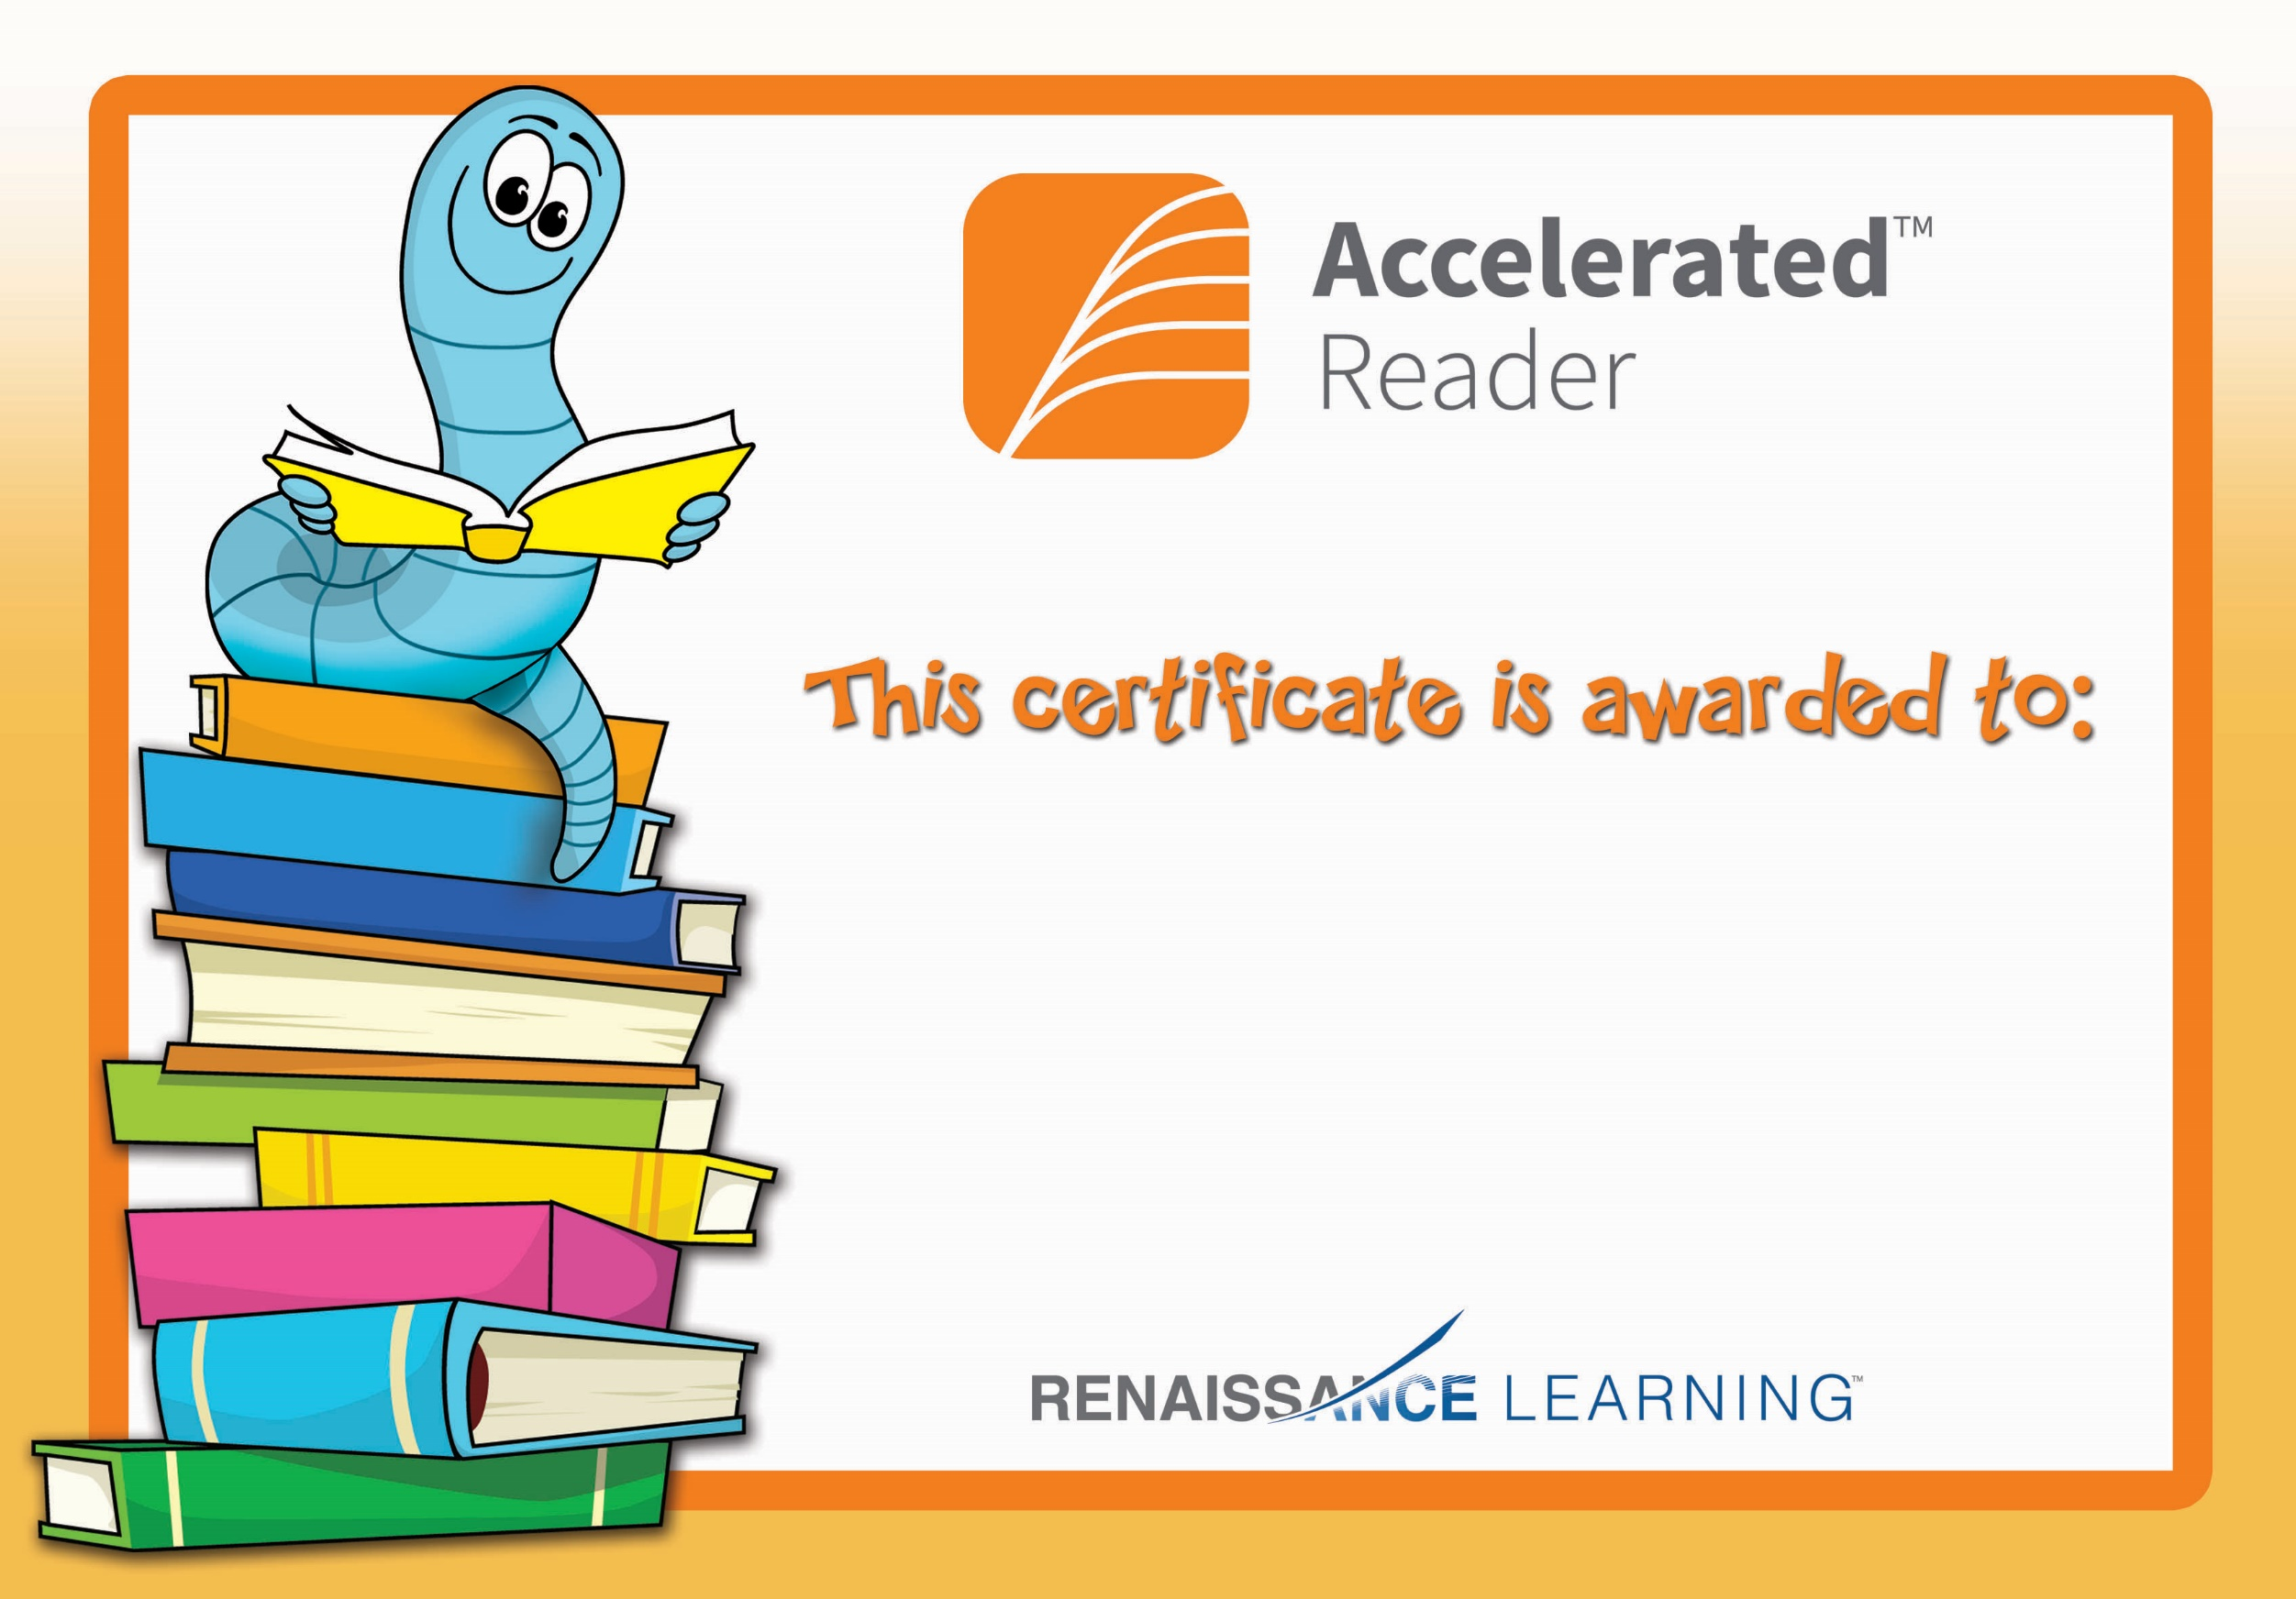

Dylan Kelly

Congratulations you reached your target.