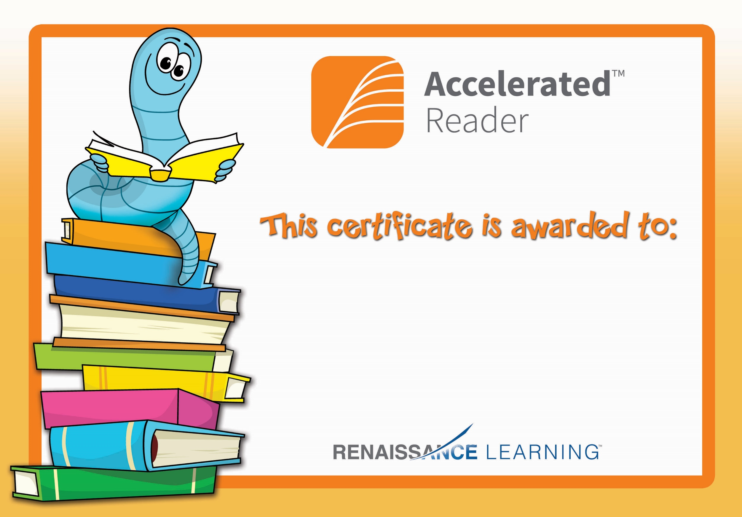

Eoghan Walters

Congratulations you reached your target.