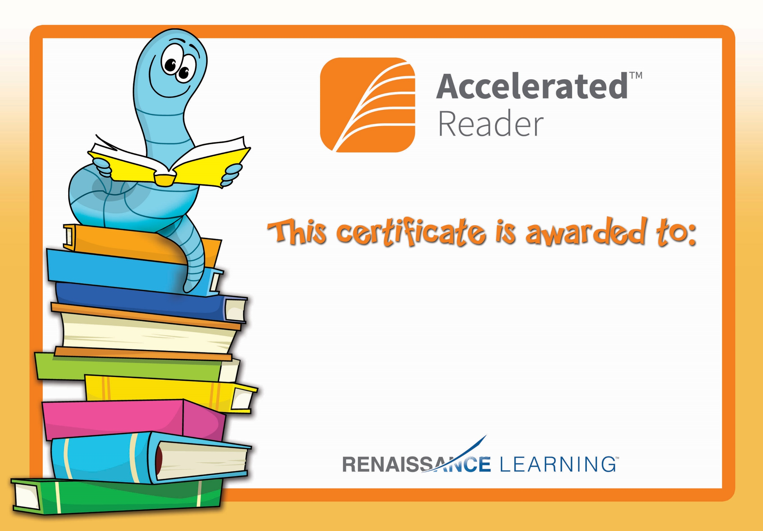

Aoife C

For reaching her AR target