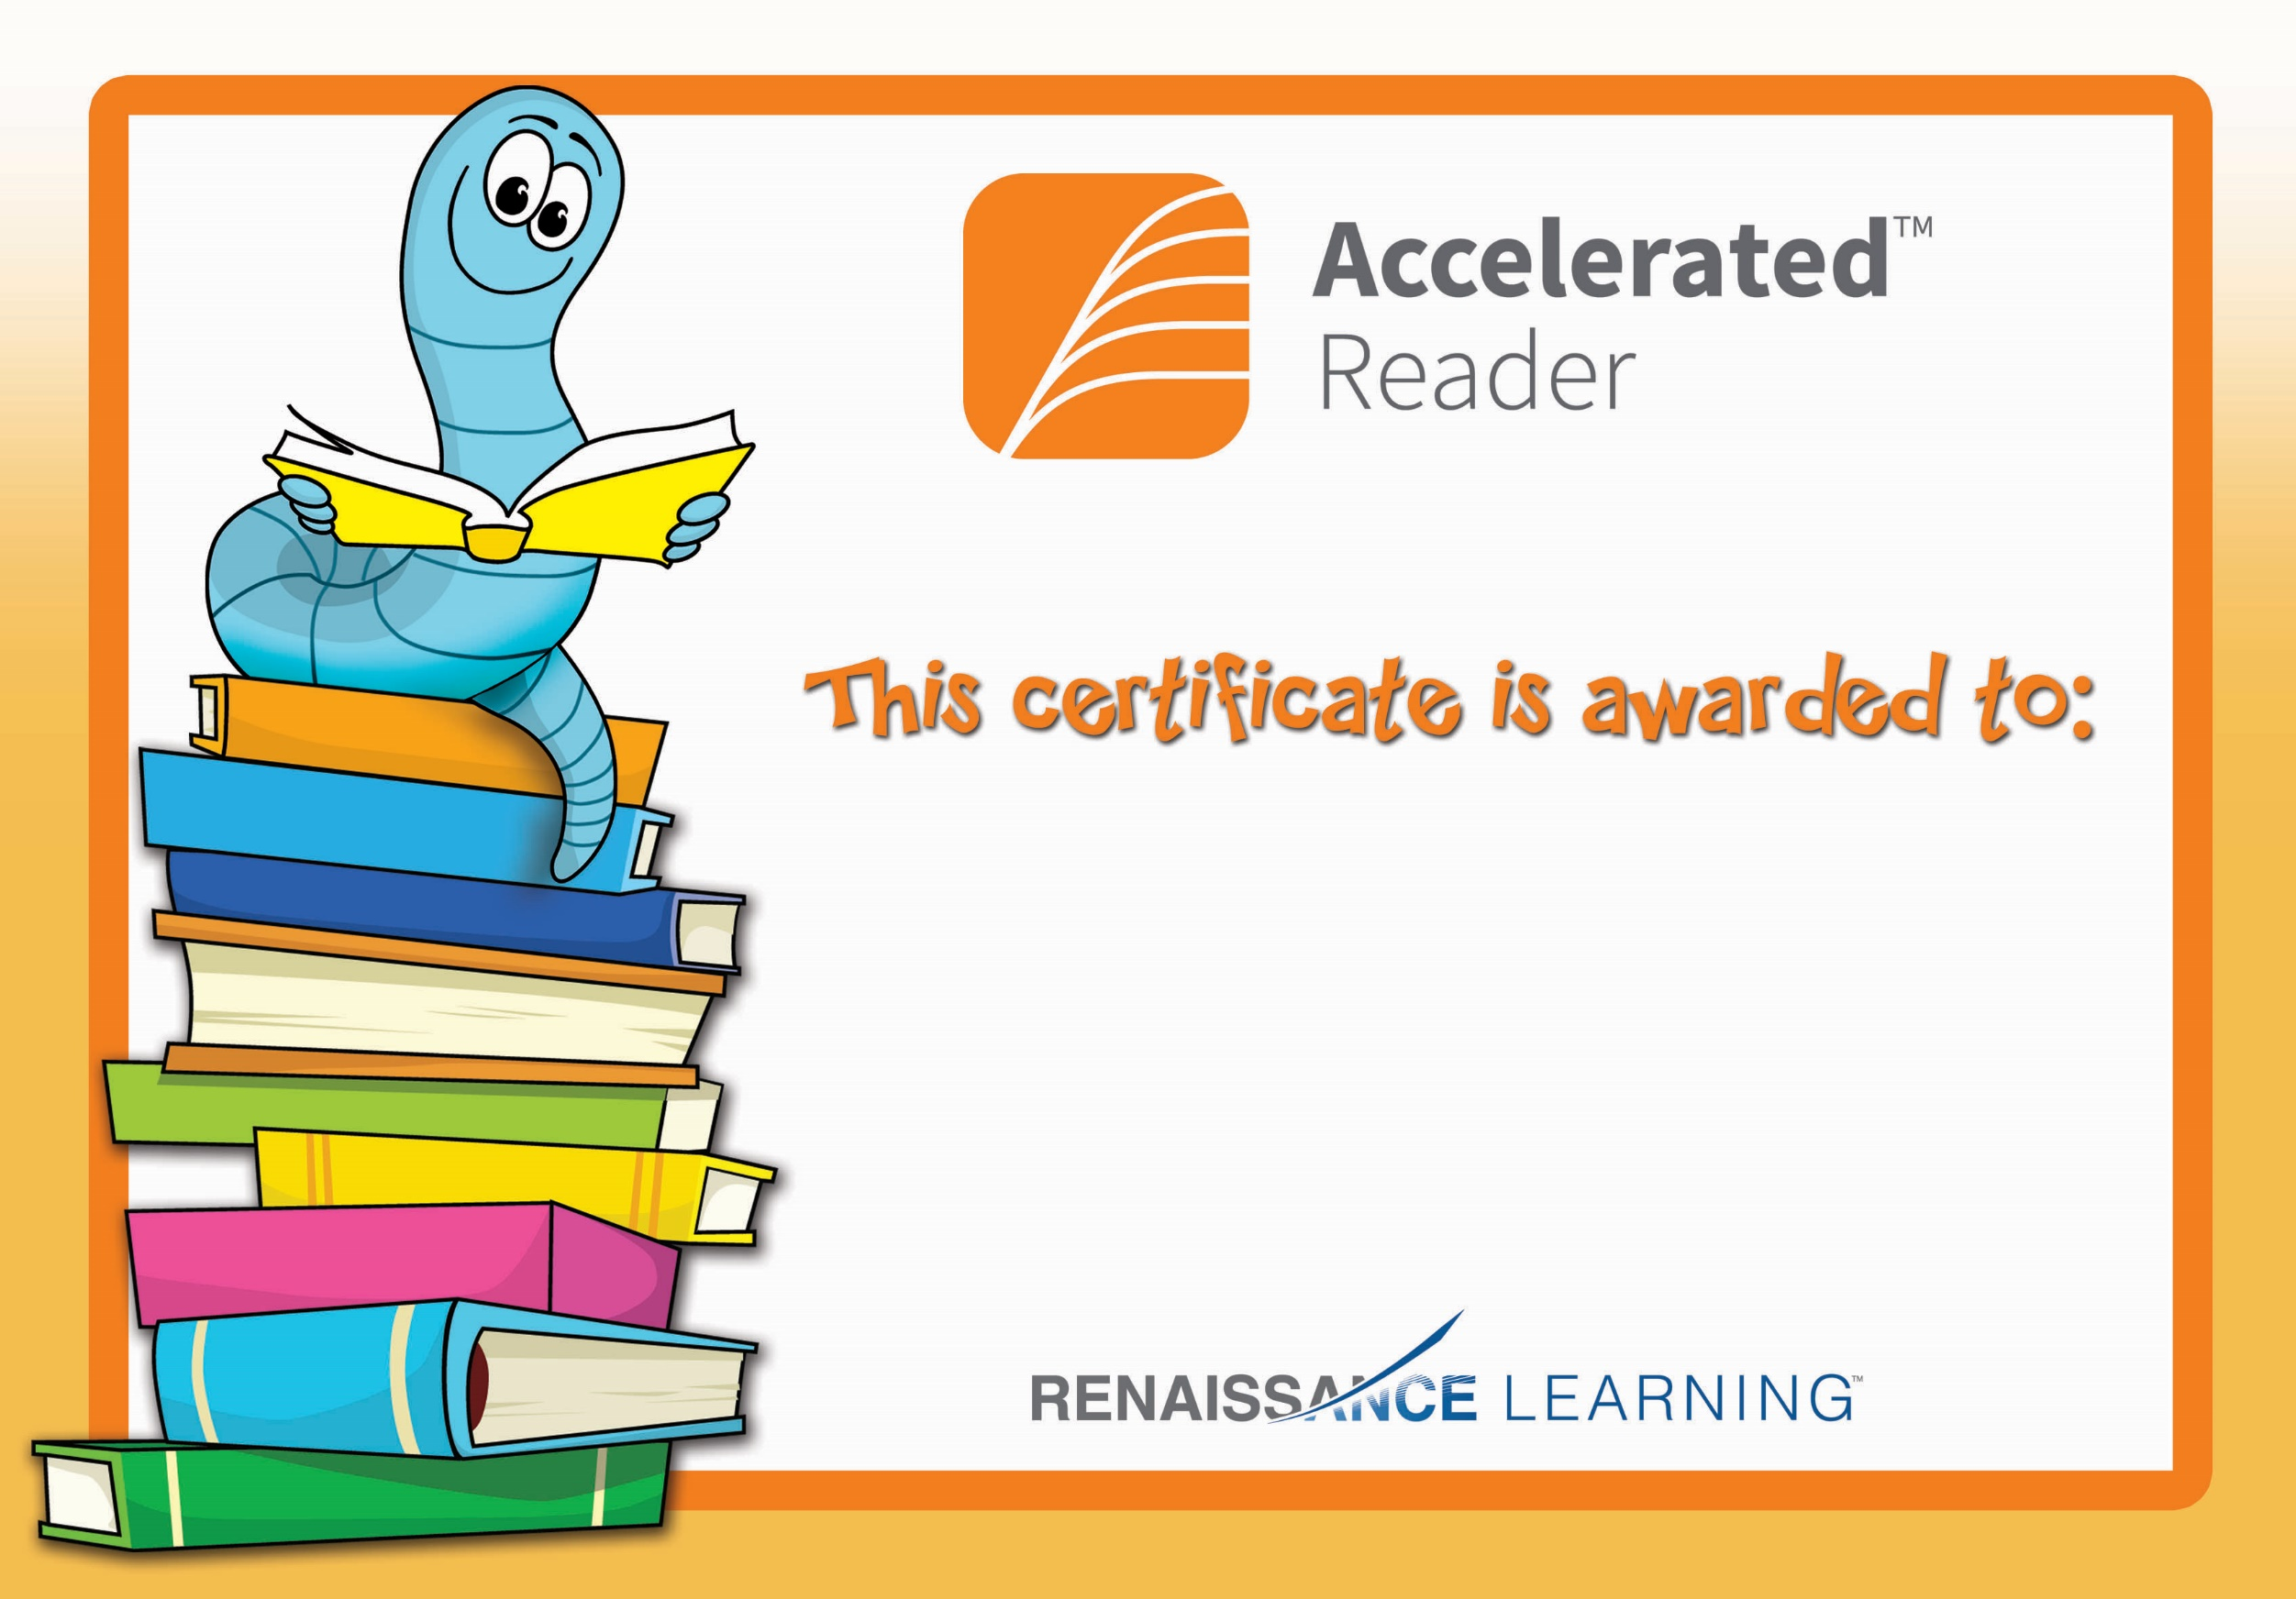

Aideen Campbell

Congratulations you reached your target.