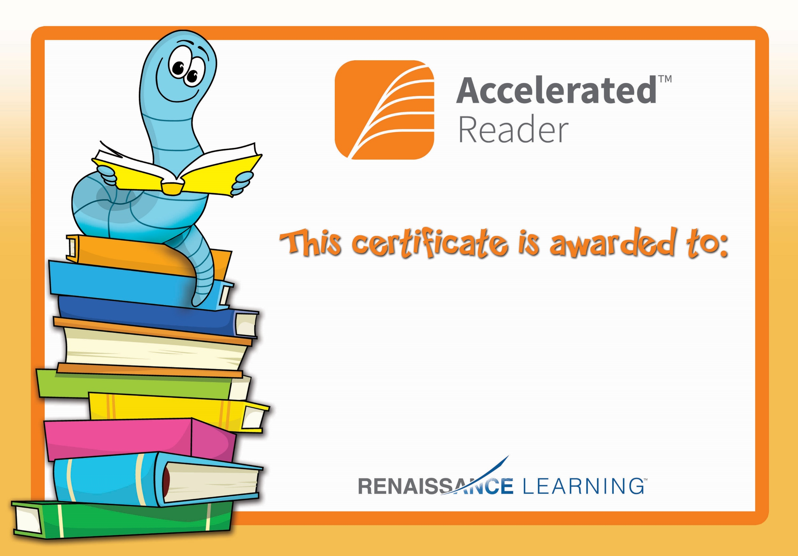

Lauren

Congratulations on reaching your Accelerated Reading target!