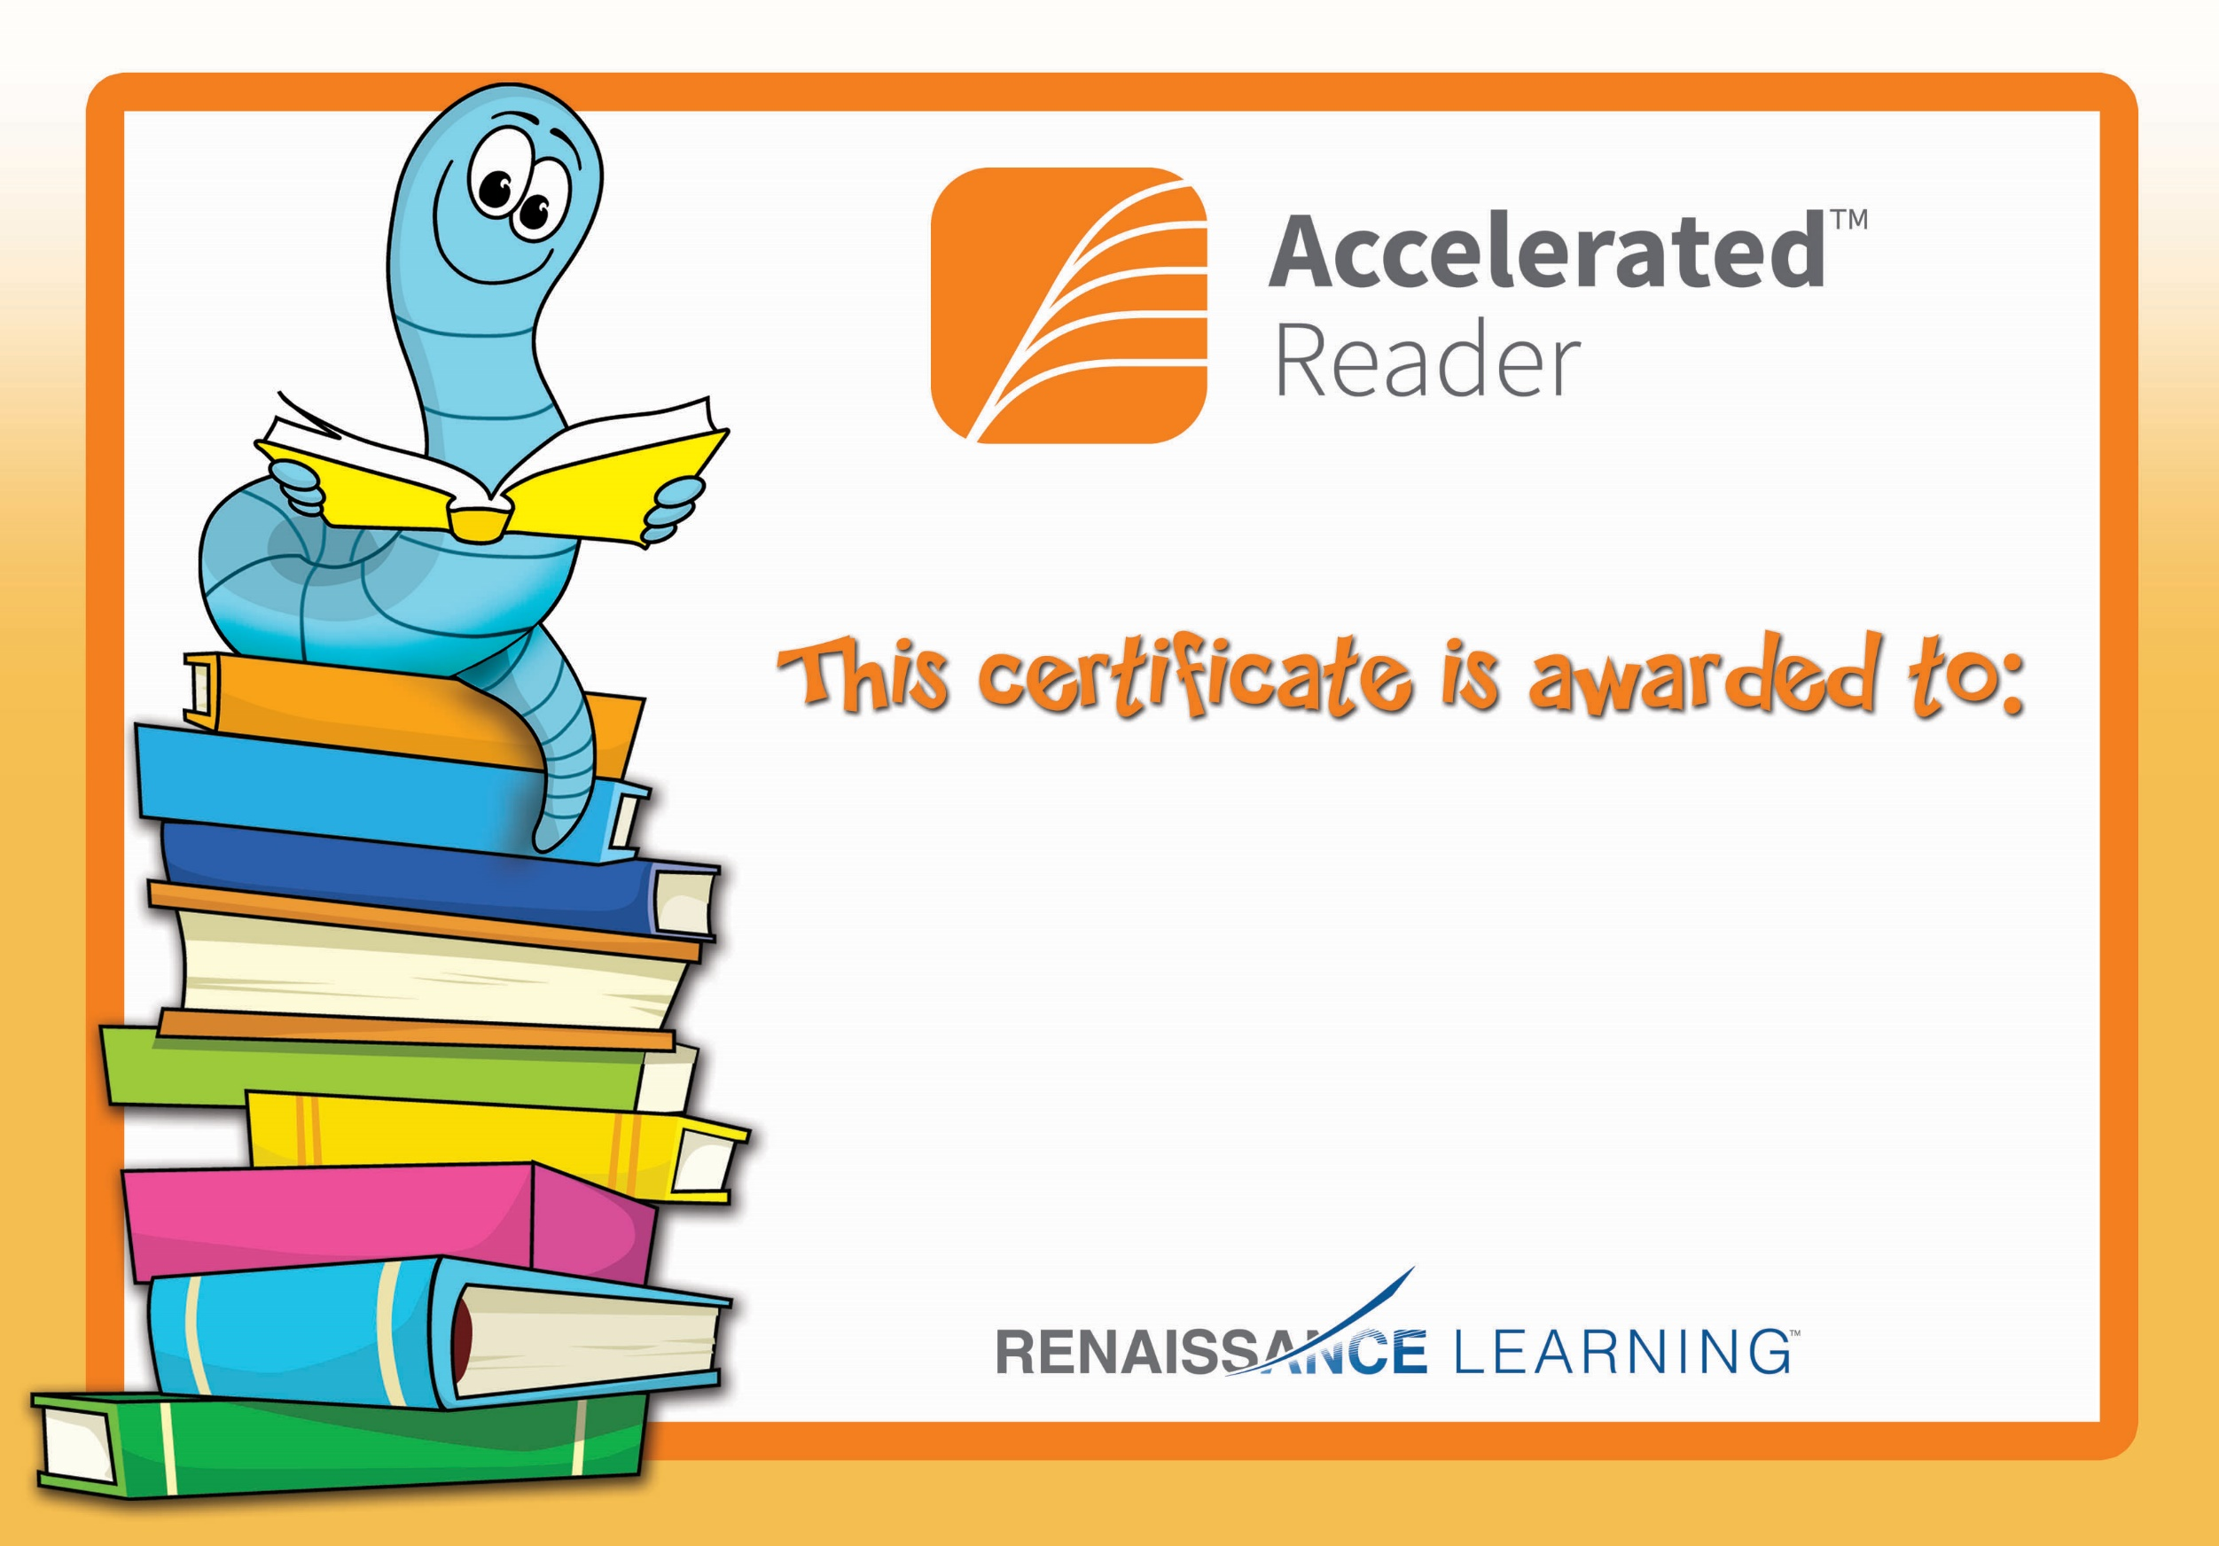

Conan

Congratulations on reaching your Accelerated Reading target!