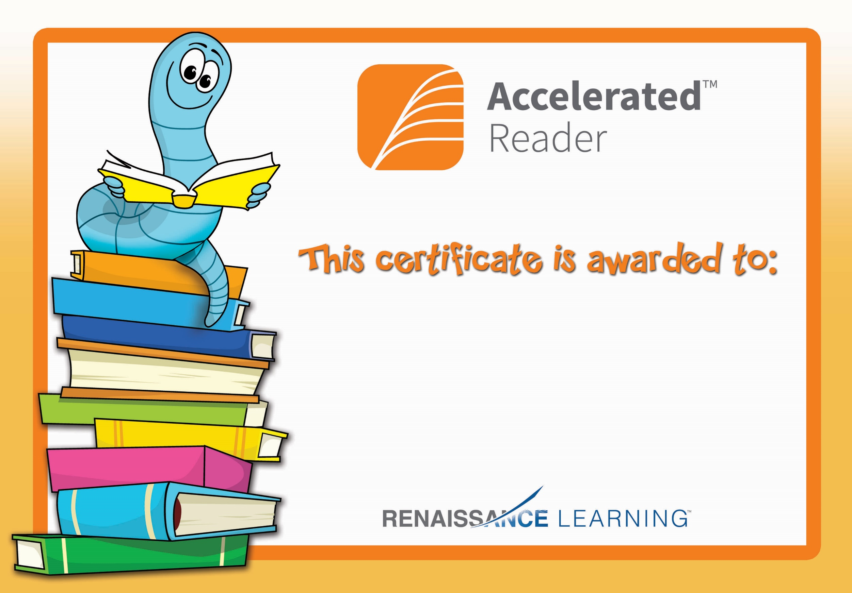

Eoin Connaghan

Congratulations you reached your target.