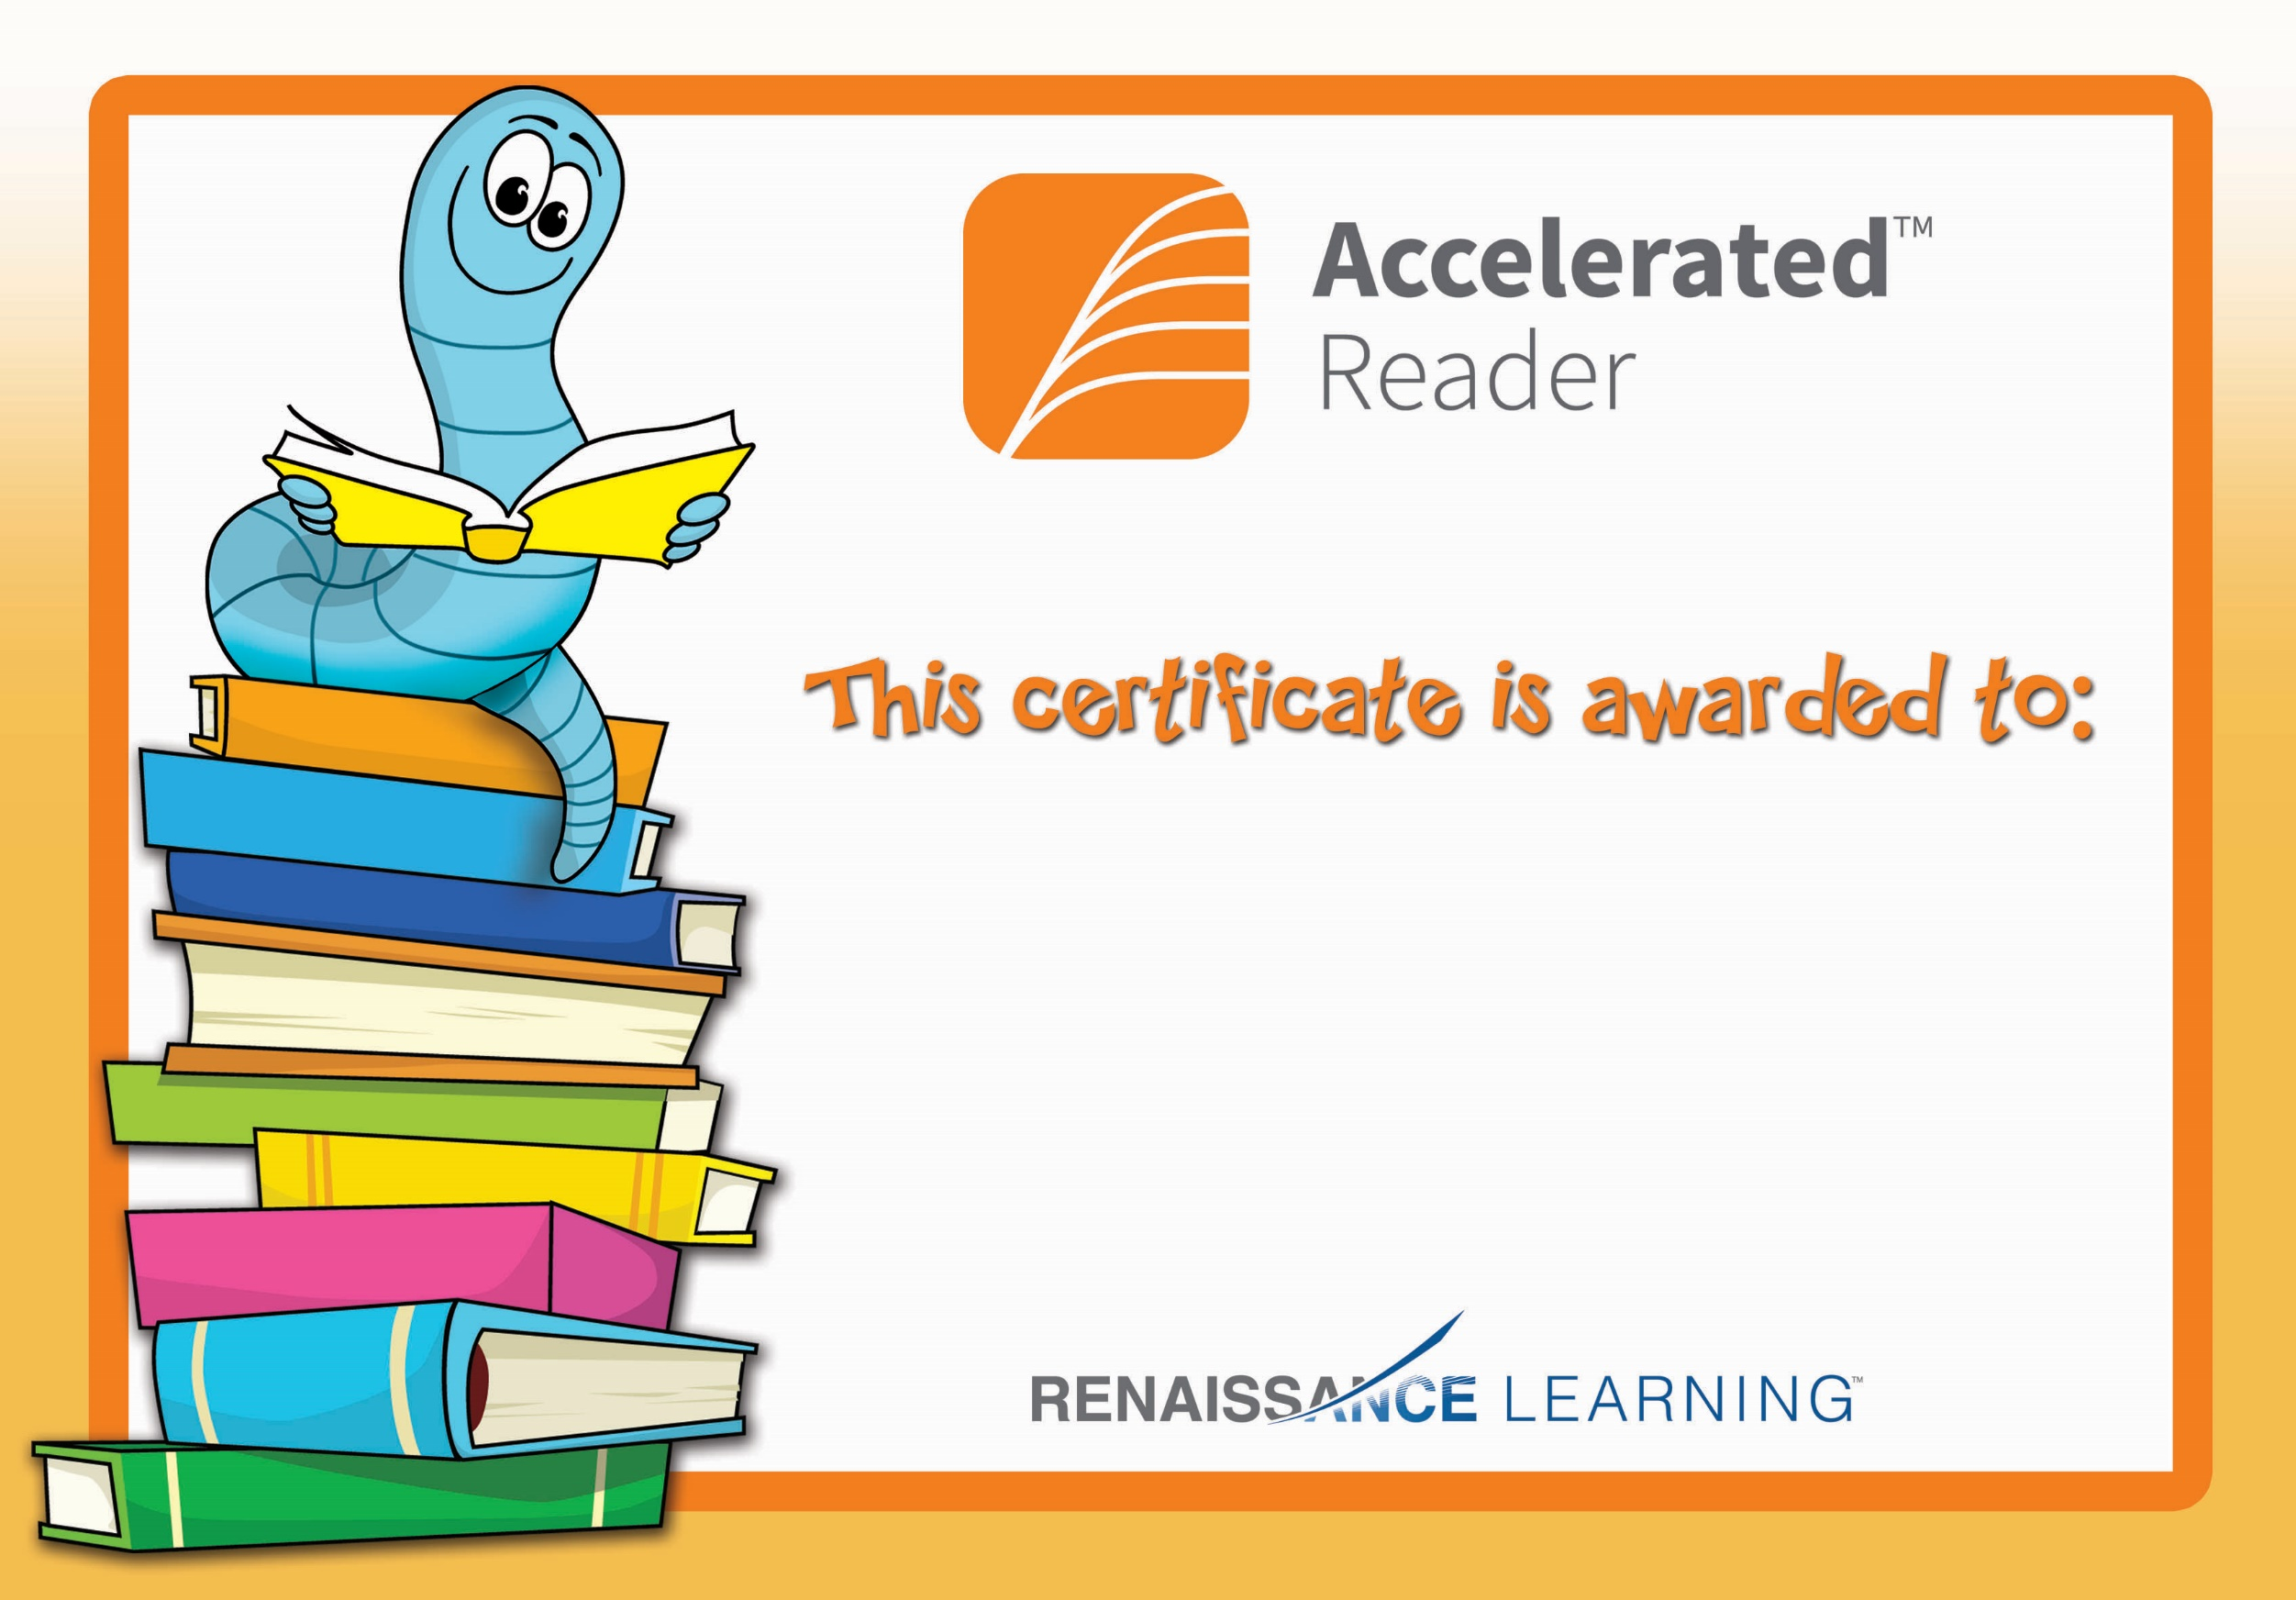

Jack Percival

Congratulations you reached your target.