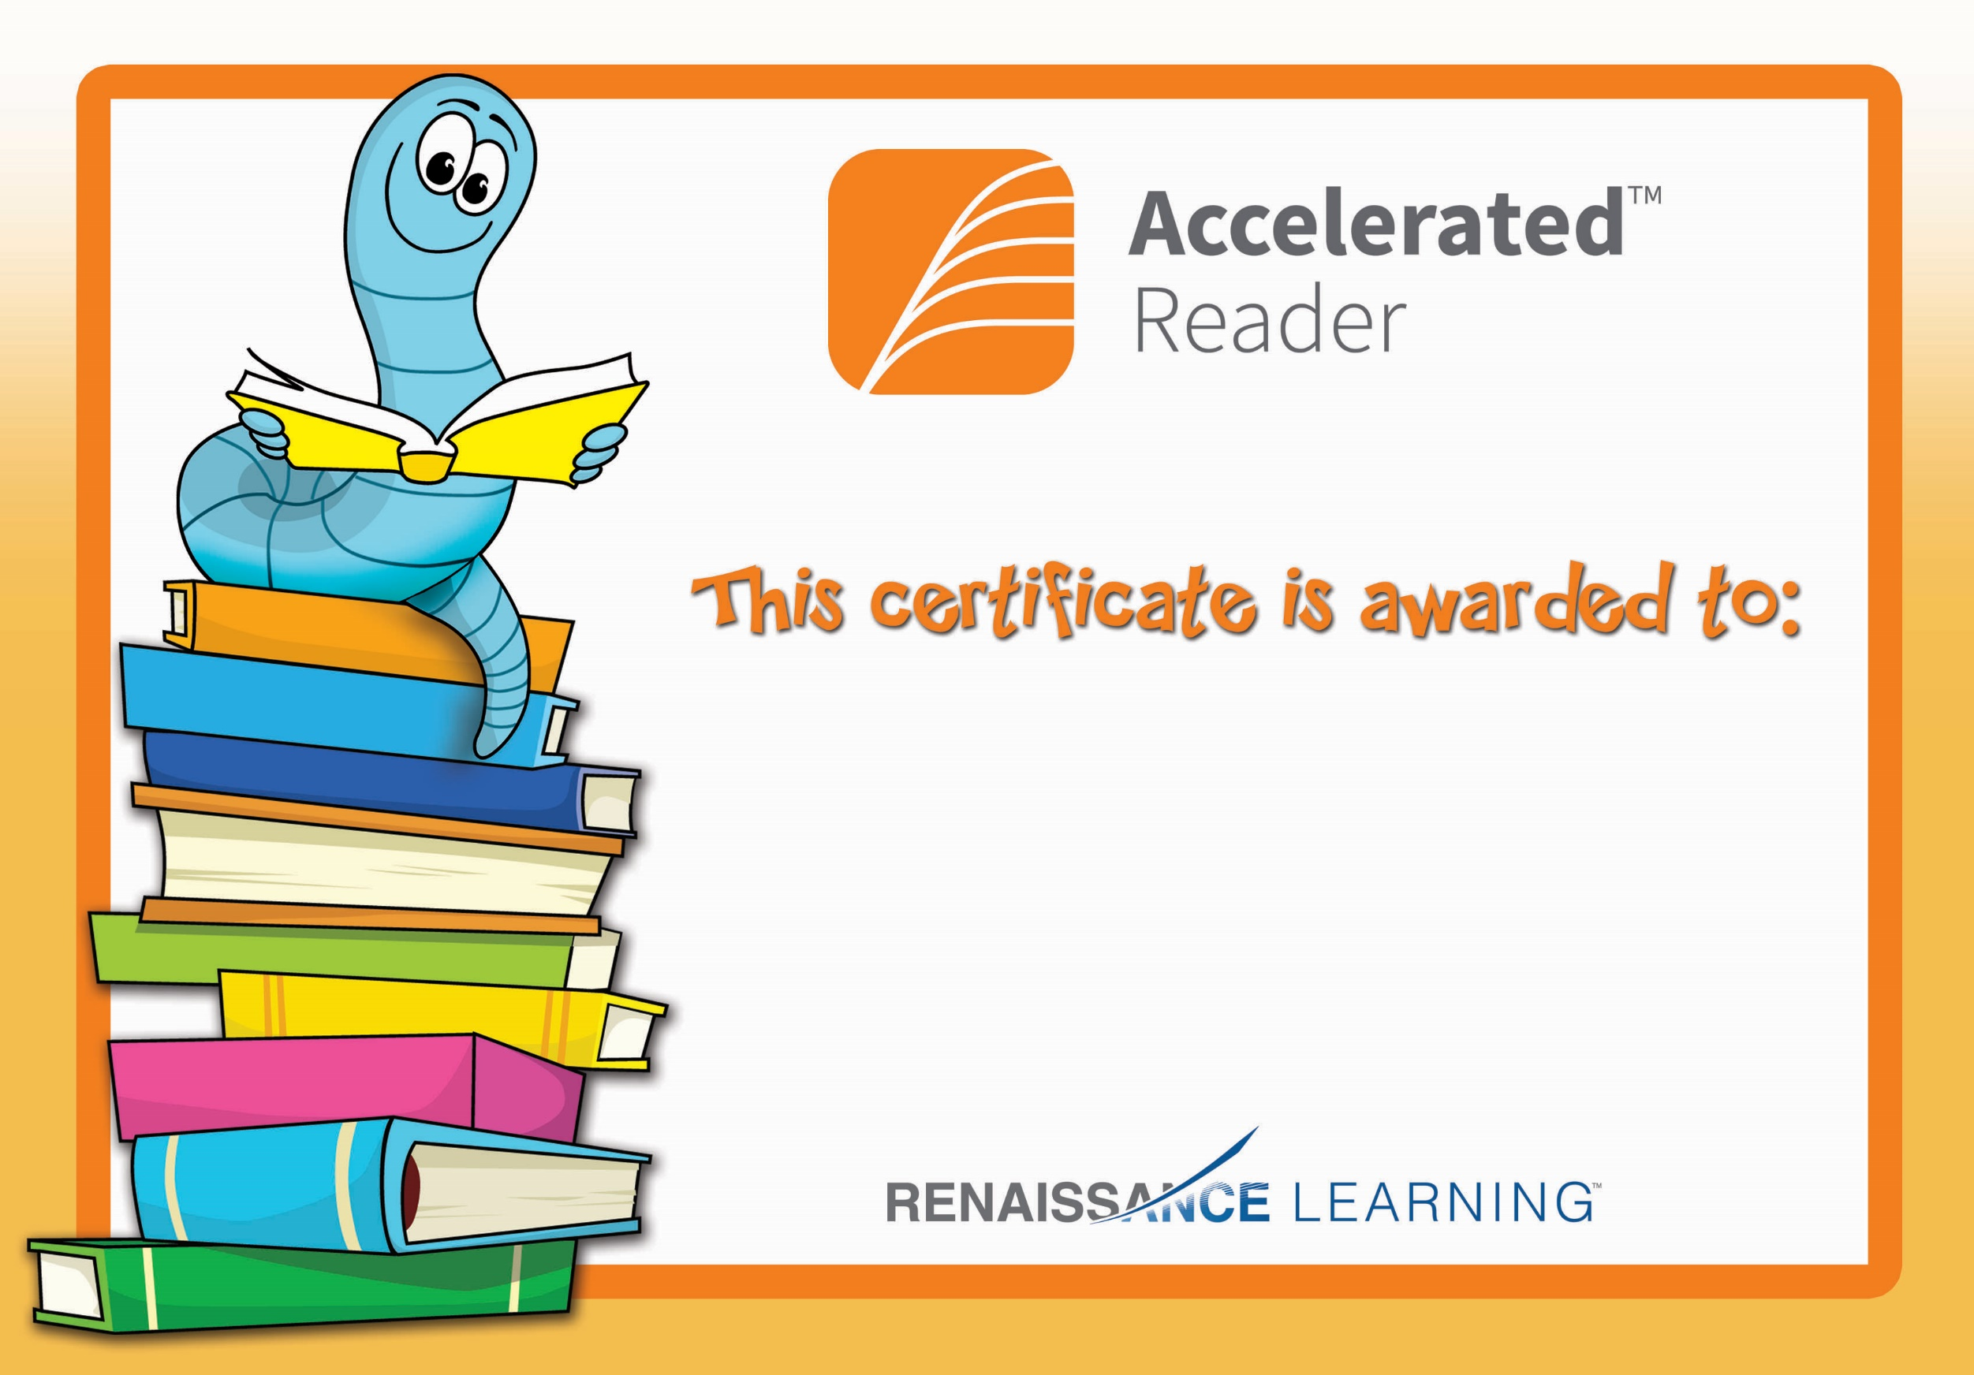

Conan Toal

Congratulations you reached your target.