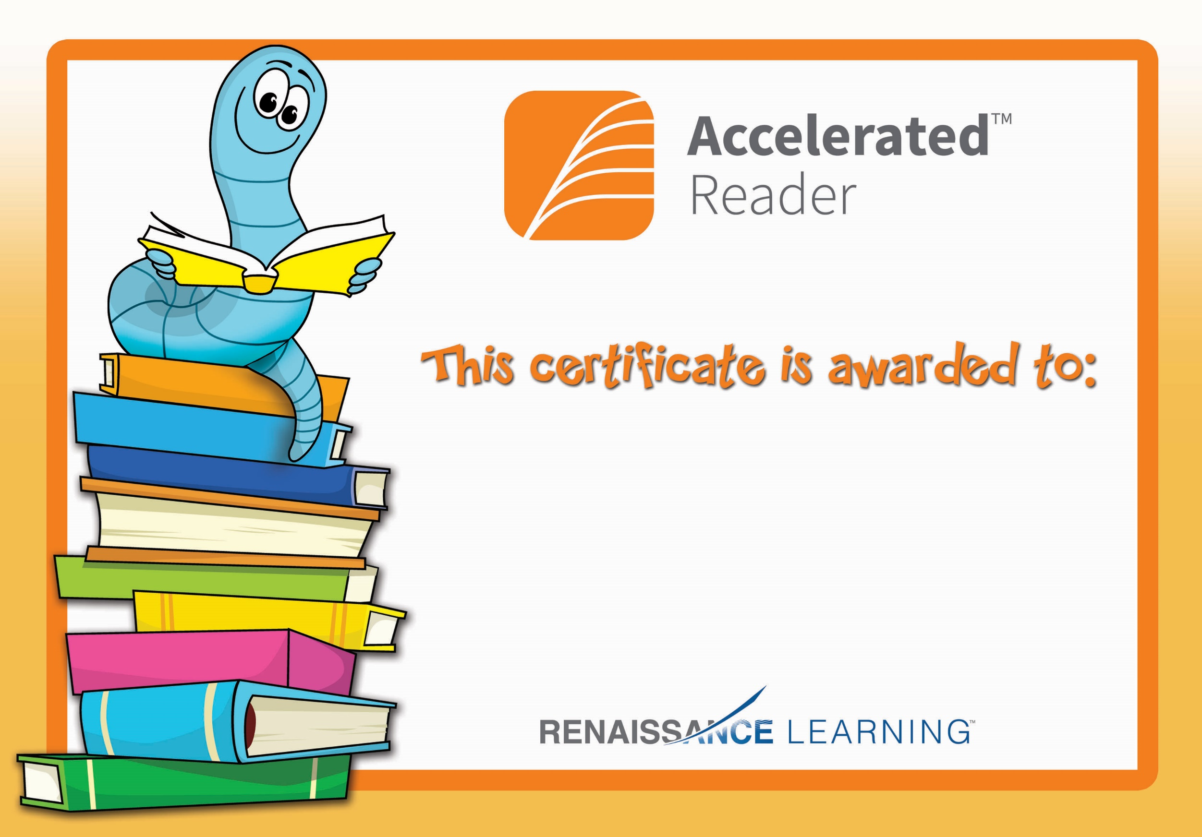

Mairead Maginn

Congratulations you reached your target.