Christmas Celebrations
Some Australians go to the beach on Christmas Day. Australians celebrate with a barbeque.

Christmas Food
Australians eat prawns, ham and turkey (but cold), oysters, barbeque and pavlova. Prawns can be served with cocktails and meat.

Christmas Gifts
People give plates of prawns. People give their old stuff away.

Christmas Decorations
Australians decorate with Christmas Bush and nativity scenes. People decorate their homes with lights, trees and ornaments.

Glossary
Pavlova – Pavlova is a dessert consisting of meringue base or shell filled with whipped cream and fruit.

Barbeque – A meal or gathering at which meat, fish or other food is cooked outdoors on a rack over an open fire.

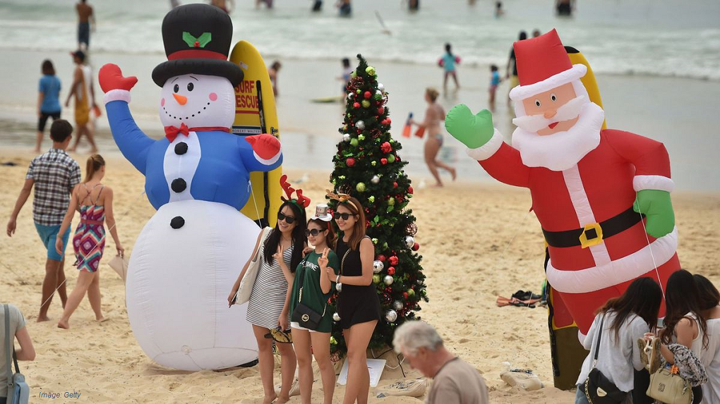
Prawns – A marine crustacean that resembles a large shrimp, many varieties of which are edible.
  - Australians Enjoying the Beach at Christmas

By Fionnbharr, Holly, Ciaran, Tiernan, Beth & Ellie-May
P4C
Tannaghmore P.S.

