Christmas Celebrations
Germans celebrate in their house. Germans celebrate on the 24th of December. Germans celebrate with two free holidays on the 25th and 26th December.

Christmas Food
Germans eat a cake called Stollen on 25th December. Stollen takes three hours and twenty minutes to cook.

Christmas Gifts
Children put their stockings up on Christmas Eve. Gifts are exchanged on 24th December.

Christmas Decorations
Many town squares have their own tall Christmas trees. Germans put their trees up on 24th December.

Glossary
Stollen – A rich German fruit and nut loaf.
Christmas Stockings – A long sock similar receptacle hung up by children on Christmas Eve for Father Christmas to fill with presents.
Christmas Tree – Long before the advent of Christianity plants and trees that remained green all year had a special meaning for people in Winter.

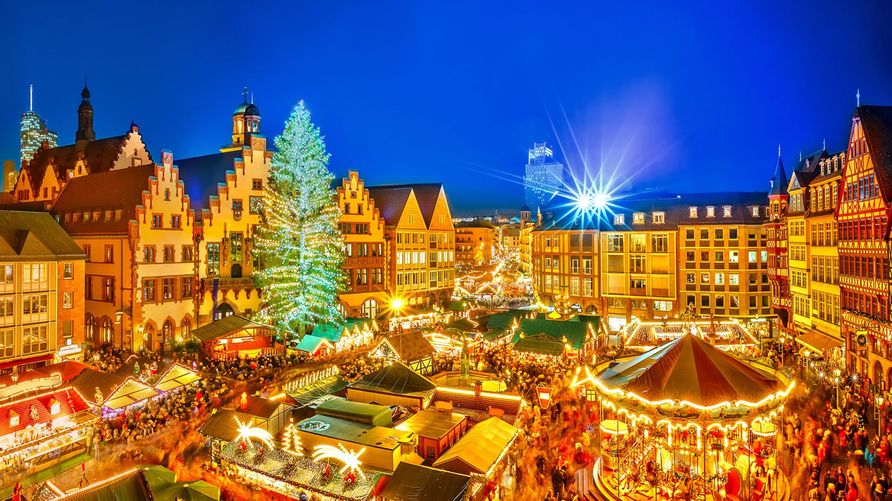

  - A German Town Square at Christmas

By Molly-Marie, Seth, Elena, Oliver, Annie & Cianan
P4C
Tannaghmore P.S.

