Christmas Celebrations
Italians celebrate from early December, the 5th. People ski down the mountain at midnight.

Christmas Food
In Italy they eat baked pasta on Christmas Day. They have a feast called ‘The Seven Fishes’.

Christmas Gifts
In Italy they get snow globes from their grannies and grandas. Italian children hang up their stocking on the 6th of January.

Christmas Decorations
Italians put up handmade Nativity scenes everywhere. In Italy the tree is decorated with dried fruit.

Glossary
Feast – A large meal typically a celebratory one.

Nativity – Birth of Jesus Christ.

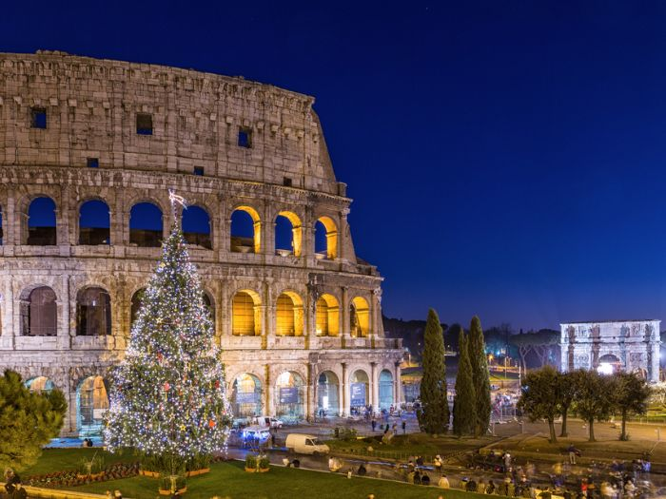
Pasta – This is a reference to the dough made from a combination of flour and water or eggs.
  - The Colosseum at Christmas, Rome, Italy.

By Grace, Tadhg, Enda, Jake, Lacey & Kate
P4C
Tannaghmore P.S.

