Christmas Celebrations
They celebrate twelve days between December 24th and January 6th. During December months the market stalls open.

Christmas Food
They eat red pork tamales and red posole. Called Noche Buena this midnight Christmas feast is filled with colourful and flavourful Mexican treats such as empanadas, bunuelos, tamales and more.

Christmas Gifts
Children in Mexico don’t receive gifts on Christmas Day. Mexican children receive gifts on 6th January.

Christmas Decorations
You will notice the people in Mexico decorate their houses with lilies and evergreens. They decorate on 23rd of December.

Glossary
Tamales – Tamales are a unique dish that is believed to have originated in Mesoamerica, the land between North & South America.

Bunuelos – They are fritters made with a mix of cheese, corn starch and yuca flour. They are crispy on the outside and soft and cheesy inside.
Noche Buena – Noche Buena is the Christmas Eve feast that begins at midnight and lasts far into Christmas morning.

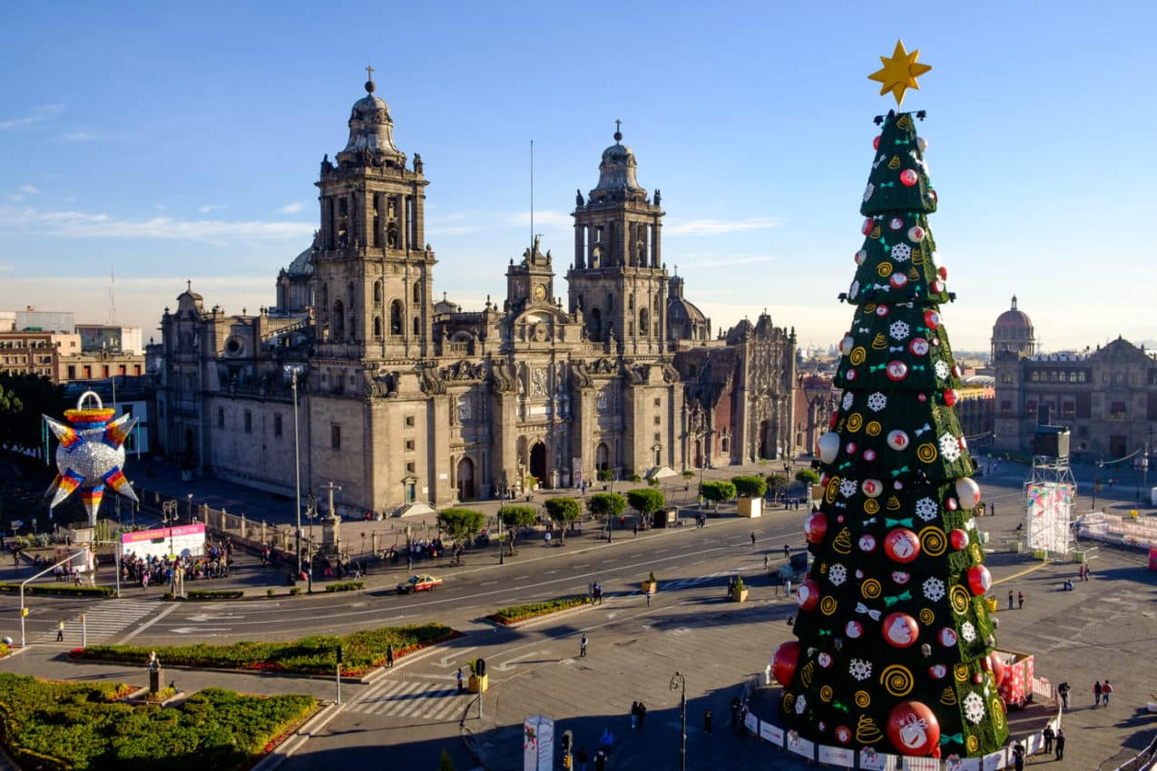
  - A Mexican Town Square at Christmas

By Lilianna, Dara, Ellie & Eoghan
P4C
Tannaghmore P.S.

