Christmas Celebrations
Christmas Eve in Spain is the most important gathering of the entire year for Spanish families. The moment Christmas Day starts right after Christmas Eve at midnight is the time where most Christmas in Western Countries gather and celebrate the Nativity of Jesus.

Christmas Food
A type of knot made of toasted almond and honey is the real star of the dessert table. At the end of the meal typical Christmas sweets are served including turron, marzipan and polvorones among many others.

Christmas Gifts
Gifts are received by 30% of people with 24% getting cash or gift cards as presents. People in Spain receive practical gifts at Christmas.

Christmas Decorations
The pinata is made with papier mache and cardboard and covered with coloured tissue paper fringes filled with candied fruits and small toys. It hangs from a rope and is repeatedly beaten by children with a wooden stick at Christmas. Nativity scenes called Belenes are very typical in Spanish cities and homes.

Glossary
Polvoron – Polvoron is a type of shortbread made of flour, sugar, milk and nuts.
Turron – Turron is a Spanish form of nougat made from almonds and honey.
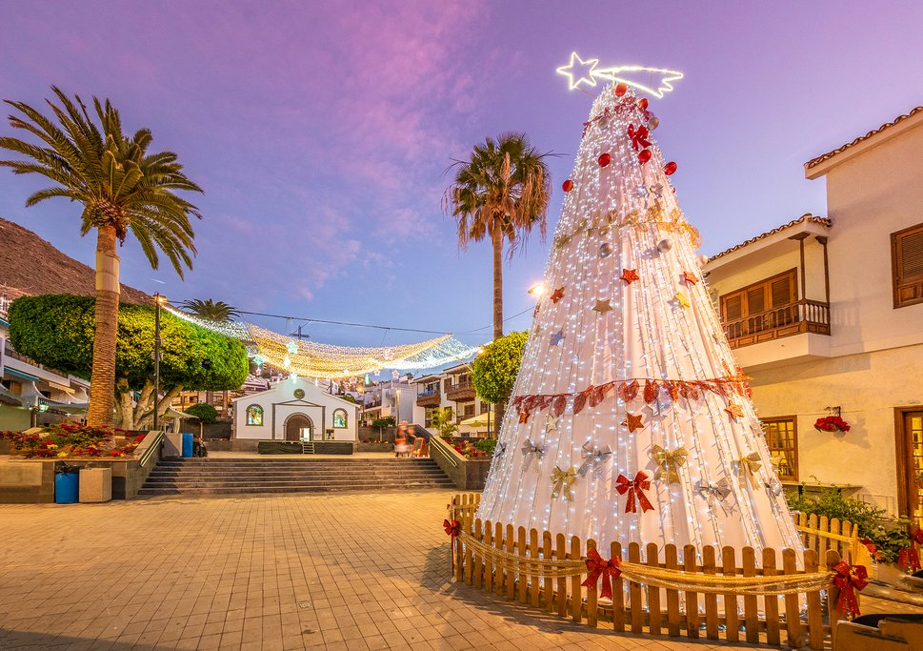
Belenes – Belenes is a nativity scene, in Spain it is traditional to have a belen at home at Christmas.

  - A Large Outdoor Nativity in Spain
By Evie, Aibhne, Bobby & Eoghan
P4C
Tannaghmore P.S.

