Christmas Celebrations
The Americans go to church on Christmas Day to celebrate the birth of Jesus. Popular customs include exchanging gifts and more.

Christmas Food
People in USA eat roasted ham, turkey, cranberry sauce and other food for Christmas Day. They usually eat Christmas dinner on Christmas Day.

Christmas Gifts
On Christmas Day people exchange gifts as in little treats and more. Stockings are hung up by children wanting a small gift. Santa did not always wear red clothes, he wore clothes that were green, purple or blue.

Christmas Decorations
The display of Christmas in USA includes statues of Santa and Christmas lights. Traditionally people in USA decorate their houses in December.

Glossary
Cranberry – A small red acid berry used in cooking.

Christmas Stocking – A large sock that children leave out when they go to bed the night before Christmas so that it can be filled with presents.

Decorate – Make something look more attractive by adding extra items or images to it.

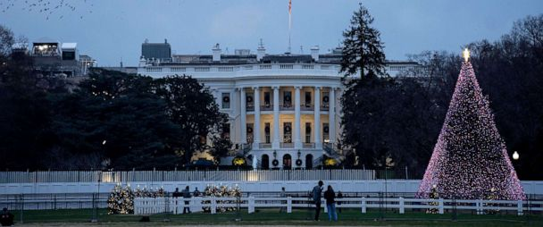
  - The White House at Christmas, Washington D.C., USA

By Lana, Matthew, Cayden & Eoghan H
P4C
Tannaghmore P.S.

